React.js Client Parking App: Step-by-Step

- 20 lessons
- 21050 words
- March 2023
- React 18
Become a Premium Member

About this course
This is a step-by-step course on how to create a React.js application for the existing separate Laravel-based API. The example Parking API is taken from the course Build Laravel API for Car Parking App: Step-By-Step, in this follow-up course we're creating a front-end React app.
Notice: This is not a Laravel SPA, it's a front-end course with React.js. It often makes sense to have front-end knowledge, if your company wants to create separate clients for web and mobile, with the same Laravel API.
Here are a few screenshots from the final front-end application:
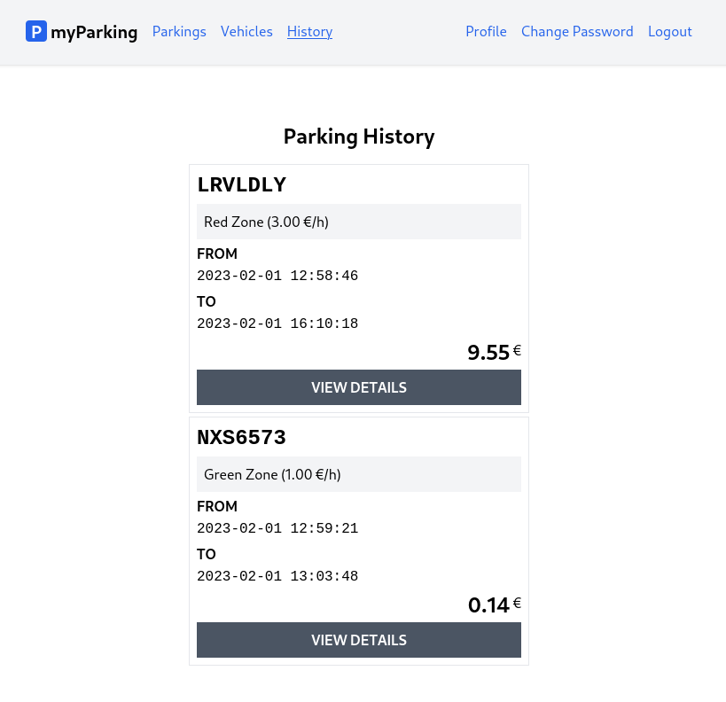
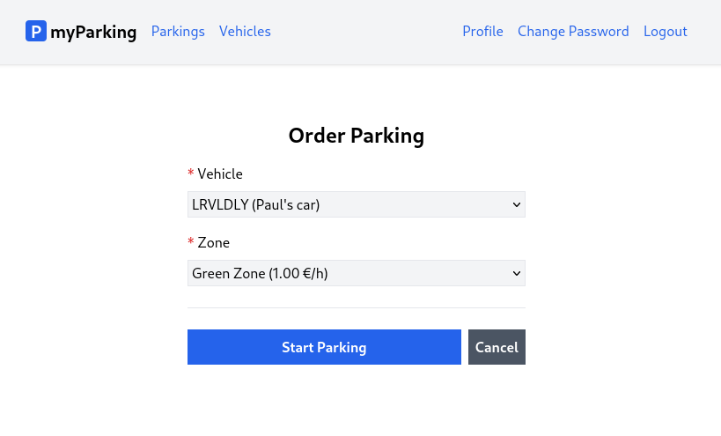
This course was co-created with David Lun, a core Laravel Daily Team member.
The code will also be fully available as a repository on GitHub.
Student's comment after the course:


Installation and Preparation

- 01

Creating a React Application
220 words
- 02

Project setup
965 words

User Authentication

- 03

React routing
731 words
- 04

Named routes
688 words
- 05

Register page
801 words
- 06

Register implementation
1511 words
- 07

Validation and register form
961 words
- 08

Loading state and register form
1051 words
- 09

Authentication
1882 words
- 10

Login page
1211 words
- 11

Edit profile page
1868 words
- 12

Change password page
811 words

Managing Vehicles

- 13

Create a vehicle
793 words
- 14

Vehicles list
577 words
- 15

Edit vehicle
1604 words
- 16

Delete vehicle
764 words

Start/Stop Parking

- 17

Order new parking page
1454 words
- 18

Active parkings and Stop parking
585 words
- 19

Parking history page
1170 words
- 20

Parking details page
1403 words

In this lesson, we will introduce how to scaffold a React Single Page Application on your local machine. The created project will be using a build setup based on Vite.
A few reasons we chose Vite over create-react-app (CRA) is because it is widely used in Laravel, so probably many of you are already familiar with Vite. As an application grows in size and complexity CRA performance tends to slow down.
Prerequisites
- Vite requires Node.js version 14.18+, 16+ or higher. Please upgrade if your package manager warns about it.
- Familiarity with the command line
Run the following command in your command line to set up a new React project.
npm init vite@latest
We have selected the following options.
✔ Project name: … React-Car-Parking-App-Demo
✔ Select a framework: › React
✔ Select a variant: › JavaScript

Scaffolding project in ./React-Car-Parking-App-Demo...

Done.
Once the project is created, follow the instructions to install dependencies and start the development server.
cd React-Car-Parking-App-Demo
npm install
npm run dev
When the server starts you will be prompted that the server is ready and the URL to access it will be shown. Optionally you can hit o key to open URL in the browser.

VITE v4.1.1 ready in 329 ms

➜ Local: http://localhost:5173/
➜ Network: use --host to expose
➜ press h to show help
In your browser, you should see the default template.
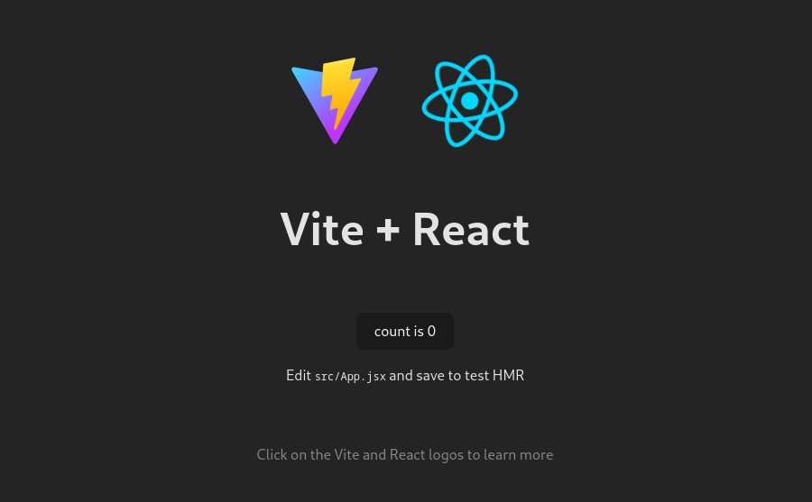
Now we have a default app with basic counter implementation with sample code to see how the state works in React. We don't need this basic scaffolding for our application and in addition, we're going to use TailwindCSS to style the application.

1. Remove unnecessary files
This is the list of files we won't need in our project, you can delete them since we are not going to use them.
deleted: src/App.css
deleted: src/assets/react.svg
deleted: src/index.css

2. Install TailwindCSS
Installing TailwindCSS as a PostCSS plugin is the most seamless way to integrate it with build tools like Vite.
Install tailwindcss and its peer dependencies via npm.
npm install -D tailwindcss postcss autoprefixer
After installation run this command to publish the initial TailwindCSS configuration.
npx tailwindcss init
A new tailwind.config.cjs file will be created in the project root directory.
Now update this file to:
const colors = require('tailwindcss/colors')

/** @type {import('tailwindcss').Config} */
module.exports = {
content: ['./src/**/*.jsx'],
theme: {
extend: { colors },
},
plugins: [],
}
The following changes were applied:
- extended configuration to include more colors, so any setting will work out of the box to play around.
- and added the './src/**/*.jsx' value to the content key so TailwindCSS will look at all React's jsx files in the ./src folder for classes to compile.
More information on how to configure TailwindCSS can be found in official documentation.
Now manually create a new postcss.config.cjs configuration file in the project root directory with the following content.
module.exports = {
plugins: {
tailwindcss: {},
autoprefixer: {},
},
}
Create a new src/assets/main.css file with the predefined CSS classes we are going to use for this demo project. Tailwind's @apply directive extracts repeated utility patterns to custom CSS classes, so instead of defining them every time on each element we basically "group" them.
@tailwind base;
@tailwind components;
@tailwind utilities;

@layer components {
label.required {
@apply before:text-red-600 before:content-['*'] before:mr-1;
}

.form-input {
@apply p-1 border bg-gray-100 disabled:opacity-50;
}

.heading {
@apply font-bold text-2xl mb-4 text-center;
}

.btn {
@apply inline-flex items-center gap-2 justify-center p-2 font-bold relative disabled:!opacity-50 disabled:!cursor-progress;
}

.btn-primary {
@apply text-white bg-blue-600 hover:bg-blue-500;
}

.btn-secondary {
@apply text-white bg-gray-600 hover:bg-gray-500;
}

.btn-danger {
@apply text-white bg-red-600 hover:bg-red-500;
}

.alert {
@apply border px-4 py-3 rounded relative;
}

.alert-danger {
@apply text-red-700 bg-red-100 border-red-400;
}

.alert-success {
@apply text-green-700 bg-green-100 border-green-400
}

.plate {
@apply font-mono font-bold uppercase;
}
}

3. Vite Config
Update Vite config vite.config.js with the following content.
import { defineConfig } from 'vite'
import react from '@vitejs/plugin-react'
import { fileURLToPath, URL } from 'node:url'

// https://vitejs.dev/config/
export default defineConfig({
plugins: [react()],
resolve: {
alias: {
'@': fileURLToPath(new URL('./src', import.meta.url)),
},
},
})
Here we imported the fileURLToPath function from the node and defined resolve.alias for our components so we can use the @ alias to define global paths when importing components instead of relative ones. This makes life easier if you later decide to move some components to different folders.

4. Update Project Files
After removing files not needed and the Vite configuration update we also need to update existing project files to get rid of any dead references and test if our TailwindCSS works.
Update the src/App.jsx file with the following content.
function App() {
return (
<div className="p-4">
<h1 className="heading">Vite + React</h1>
<div className="text-red-600">
<p>
Edit <code>src/App.jsx</code> and save to test HMR
</p>
</div>
</div>
)
}

export default App
And update the src/main.jsx file.
import React from 'react'
import ReactDOM from 'react-dom/client'
import App from '@/App'
import '@/assets/main.css'

ReactDOM.createRoot(document.getElementById('root')).render(
<React.StrictMode>
<App />
</React.StrictMode>,
)
Now after restarting Vite and reloading the page you should see this page with some simple styling.
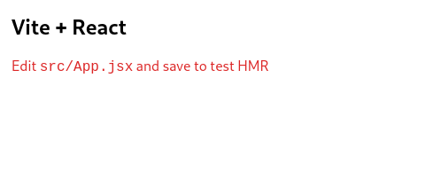

5. Configure eslint
In this last step we are going to configure eslint as our linter for this project.
ℹ️ This step is optional, you can skip it and complete all course material without it.
ESLint is a tool for identifying and reporting on patterns found in ECMAScript/JavaScript code, to make code more consistent and avoid bugs.
This is especially useful if you are planning to work in a team. There's a high chance that there will be some sort of tool to enforce specific code styles and patterns.
Install eslint with react plugins to allow the linter better understand the code with the following command.
npm install -D eslint eslint-plugin-jsx-a11y eslint-plugin-react eslint-plugin-react-hooks
Create a new file .eslintrc.cjs in the project root directory.
/* eslint-env node */
module.exports = {
root: true,
env: {
browser: true,
es2021: true,
},
extends: [
'eslint:recommended',
'plugin:react/recommended',
'plugin:react/jsx-runtime',
'plugin:jsx-a11y/recommended',
],
overrides: [],
parserOptions: {
ecmaVersion: 'latest',
sourceType: 'module',
ecmaFeatures: {
jsx: true,
},
},
plugins: ['react', 'react-hooks', 'jsx-a11y'],
rules: {
'no-undef': 'off',
'comma-dangle': ['error', 'always-multiline'],
indent: ['error', 2],
'linebreak-style': ['error', 'unix'],
quotes: ['error', 'single'],
semi: ['error', 'never'],
'react/react-in-jsx-scope': 'off',
'react-hooks/rules-of-hooks': 'error',
'react-hooks/exhaustive-deps': 'warn',
},
settings: {
react: {
version: 'detect',
},
},
}
Modern editors can detect eslint presence in your project and will highlight important places automatically, but you can also do that manually from the command line.
To do that manually you need to update the scripts section in your package.json file
from:
"scripts": {
"dev": "vite",
"build": "vite build",
"preview": "vite preview"
},
to:
"scripts": {
"dev": "vite",
"build": "vite build",
"preview": "vite preview",
"lint": "eslint . --ext .js,.jsx,.cjs,.mjs --fix --ignore-path .gitignore"
},
To lint your project now you can run this command.
npm run lint
In this lesson let's set up react router to be able to navigate between views.
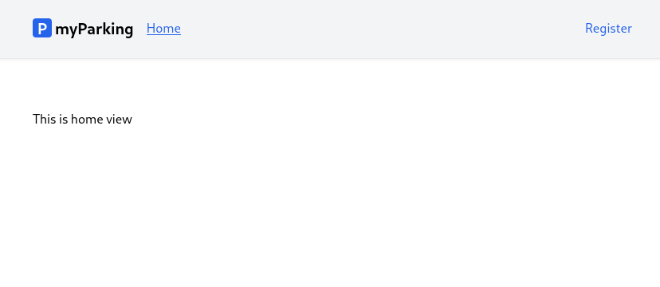
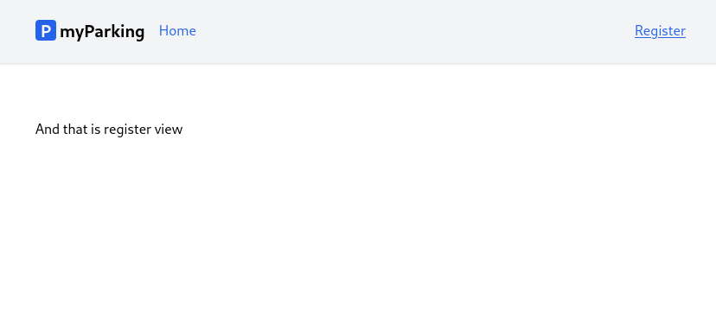
- By default react doesn't have included router so we need to install it manually with this command.
npm install react-router-dom --save
- After successful installation let's prepare the first components we are going to navigate between. Create a new file src/views/Home.jsx with the following content.
function Home() {
return <div>This is home view</div>
}

export default Home
- And new src/views/auth/Register.jsx component.
function Register() {
return <div>And that is register view</div>
}

export default Register
- Update the src/main.jsx file to this.
import React from 'react'
import ReactDOM from 'react-dom/client'
import { BrowserRouter, Routes, Route } from 'react-router-dom'
import App from '@/App'
import Home from '@/views/Home'
import Register from '@/views/auth/Register'
import '@/assets/main.css'

ReactDOM.createRoot(document.getElementById('root')).render(
<React.StrictMode>
<BrowserRouter>
<Routes>
<Route path="/" element={<App />}>
<Route index element={<Home />} />
<Route path="register" element={<Register />} />
</Route>
</Routes>
</BrowserRouter>
</React.StrictMode>,
)
Here we import BrowserRouter, Routes, and Route components from react-router-dom.
The whole app is wrapped in <BrowserRoute>. It stores the current location in the browser's address bar using clean URLs and navigates using the browser's built-in history stack.
<Routes> will match a set of child routes from the current location. Whenever the location changes, <Routes> look through all its child routes to find the best match and renders that branch of the UI. <Route> elements may be nested to indicate nested UI, which also corresponds to nested URL paths. Parent routes render their child routes by rendering an <Outlet>.
- Update the src/App.jsx file.
import { Outlet, NavLink } from 'react-router-dom'

function App() {
return (
<div className="App">
<header className="py-6 bg-gray-100 shadow">
<div className="container md:px-2 px-4 mx-auto">
<nav className="flex gap-4 justify-between">
<div className="flex gap-4 items-center">
<h2 className="text-xl font-bold">
<div
className="inline-flex items-center justify-center bg-blue-600 w-6 h-6 text-center text-white rounded mr-1"
>
P
</div>
myParking
</h2>
<NavLink end to="/" className={ ({isActive}) => {
return isActive ? 'text-blue-600 underline' : 'text-blue-600'
} }>Home</NavLink>
</div>
<div className="flex gap-4 items-center">
<NavLink end to="/register" className={ ({isActive}) => {
return isActive ? 'text-blue-600 underline' : 'text-blue-600'
} }>Register</NavLink>
</div>
</nav>
</div>
</header>
<div className="container md:px-2 px-4 pt-8 md:pt-16 mx-auto">
<Outlet />
</div>
</div>
)
}

export default App
In a place where <Outlet /> is defined will be rendered our <Home> and <Register> components when the route defined matches them.
A <NavLink> is a special kind of React's regular <Link> that knows whether or not it is "active". This is useful when building a navigation menu where you'd like to show which of them is currently selected. It also provides useful context for assistive technology like screen readers. You can pass a function to either style or className that will allow you to customize the inline styling or the class string based on the component's active state. You can also pass a function as children to customize the content of the <NavLink> component based on their active state, especially useful to change styles on internal elements.
It looks like this.
<NavLink end to="/" className={ ({isActive}) => {
return isActive ? 'text-blue-600 underline' : 'text-blue-600'
} }>Home</NavLink>
If the end prop is used like in our case, it will ensure this component isn't matched as "active" when its descendant paths are matched. For example, to render a link that is only active at the website root and not any other URLs.
Now you should have everything working and able to navigate between the newly created home and register pages.
Let's move to the next lesson.
As you already noticed, React Router doesn't have a centralized route config, so there's nothing to name. React Router provides the correct primitives and lets the community create higher-level APIs around them if needed.
This is exactly what we are going to do in this lesson.
- Create a new file src/routes/index.jsx.
const routeNames = {
'home': '/',
'register': '/register',
}

function route(name, params = {}) {
let url = routeNames[name]

for (let prop in params) {
if (Object.prototype.hasOwnProperty.call(params, prop)) {
url = url.replace(`:${prop}`, params[prop])
}
}

return url
}

export { route }
The constant routeNames is going to hold our route name as the key, and route URL as the value.
Helper function route() will act in the same way as Laravel's route() function. The first argument is going to accept the route name. The second argument will accept route parameters and then return the URL.
- Now update the src/main.jsx file with the following content.
import React from 'react'
import ReactDOM from 'react-dom/client'
import { BrowserRouter, Routes, Route } from 'react-router-dom'
import App from '@/App'
import Home from '@/views/Home'
import Register from '@/views/auth/Register'
import '@/assets/main.css'
import { route } from '@/routes'

ReactDOM.createRoot(document.getElementById('root')).render(
<React.StrictMode>
<BrowserRouter>
<Routes>
<Route path={ route('home') } element={<App />}>
<Route index element={<Home />} />
<Route path={ route('register') } element={<Register />} />
</Route>
</Routes>
</BrowserRouter>
</React.StrictMode>,
)
We imported our helper function route() and can use it like this.
<Route path={ route('register') } element={<Register />} />
Note that JavaScript is a case-sensitive language. Route and route have two completely different identities.
- We also would like to use <NavLink> in the same way. To have properties in our component first we need to install the prop-types package.
npm install prop-types --save
React.PropTypes has moved into a different package since React v15.5.
Now it is time to create a new component src/components/NamedLink.jsx to wrap that functionality inside.
import PropTypes from 'prop-types'
import { NavLink } from 'react-router-dom'
import { route } from '@/routes'

function NamedLink(props) {
return (
<NavLink
end
to={ route(props.name) }
className={({ isActive }) => isActive ?
'text-blue-600 underline' :
'text-blue-600'
}
>
{ props.children }
</NavLink>
)
}

NamedLink.propTypes = {
name: PropTypes.string.isRequired,
children: PropTypes.node.isRequired,
}

export default NamedLink
Our new <NamedLink> component has all the features of <NavLink> and has two properties.
name will be our route name, and children are the content inside this component which will be passed further to <NavLink>.
Now we can consume it like in the example below.
import NamedLink from '@/components/NamedLink'
<NamedLink name="register">
Register
</NamedLink>
- Finally update the src/App.jsx file with the following content.
import { Outlet } from 'react-router-dom'
import NamedLink from '@/components/NamedLink'

function App() {
return (
<div className="App">
<header className="py-6 bg-gray-100 shadow">
<div className="container md:px-2 px-4 mx-auto">
<nav className="flex gap-4 justify-between">
<div className="flex gap-4 items-center">
<h2 className="text-xl font-bold">
<div
className="inline-flex items-center justify-center bg-blue-600 w-6 h-6 text-center text-white rounded mr-1"
>
P
</div>
myParking
</h2>
<NamedLink name="home">
Home
</NamedLink>
</div>
<div className="flex gap-4 items-center">
<NamedLink name="register">
Register
</NamedLink>
</div>
</nav>
</div>
</header>
<div className="container md:px-2 px-4 pt-8 md:pt-16 mx-auto">
<Outlet />
</div>
</div>
)
}

export default App
Having custom components has huge benefits. Code looks cleaner, components are reusable, and reduces the number of places to update if changes are needed. For example, now you just need to update NamedLink if you want to display all links in a different color.
In this lesson, we are going to update the Register page, use state and see how to handle the form submission.
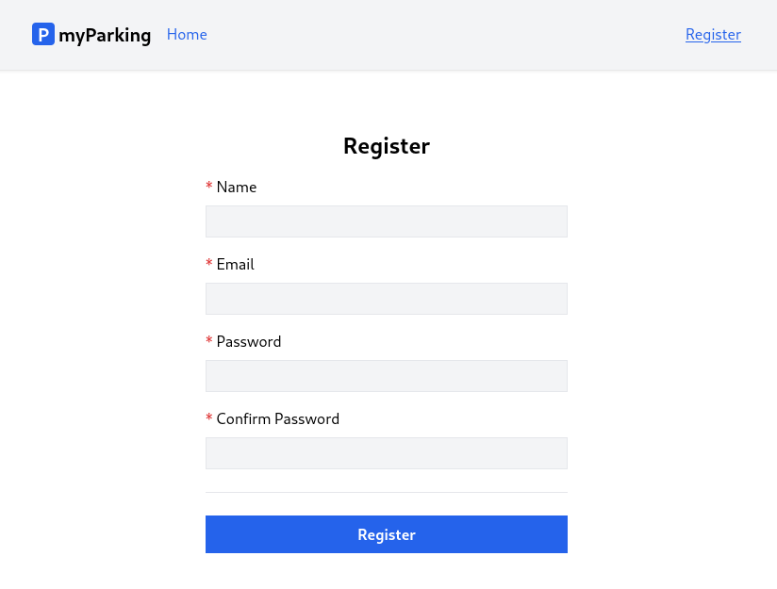
Update src/views/auth/Register.jsx with the following content.
import { useState } from 'react'

function Register() {
const [name, setName] = useState('')
const [email, setEmail] = useState('')
const [password, setPassword] = useState('')
const [passwordConfirmation, setPasswordConfirmation] = useState('')

function handleSubmit(event) {
event.preventDefault()
const data = { name, email, password, passwordConfirmation }
console.log(data)
}

return (
<form onSubmit={ handleSubmit } noValidate>
<div className="flex flex-col mx-auto md:w-96 w-full">

<h1 className="heading">Register</h1>

<div className="flex flex-col gap-2 mb-4">
<label htmlFor="name" className="required">Name</label>
<input
id="name"
name="name"
type="text"
value={ name }
onChange={ event => setName(event.target.value) }
className="form-input"
autoComplete="name"
/>
</div>

<div className="flex flex-col gap-2 mb-4">
<label htmlFor="email" className="required">Email</label>
<input
id="email"
name="email"
type="email"
value={ email }
onChange={ event => setEmail(event.target.value) }
className="form-input"
autoComplete="email"
/>
</div>

<div className="flex flex-col gap-2 mb-4">
<label htmlFor="password" className="required">Password</label>
<input
id="password"
name="password"
type="password"
value={ password }
onChange={ event => setPassword(event.target.value) }
className="form-input"
autoComplete="new-password"
/>
</div>

<div className="flex flex-col gap-2">
<label htmlFor="password_confirmation" className="required">Confirm Password</label>
<input
id="password_confirmation"
name="password_confirmation"
type="password"
value={ passwordConfirmation }
onChange={ event => setPasswordConfirmation(event.target.value) }
className="form-input"
autoComplete="new-password"
/>
</div>

<div className="border-t h-[1px] my-6"></div>

<div className="flex flex-col gap-2 mb-4">
<button type="submit" className="btn btn-primary">
Register
</button>
</div>
</div>
</form>
)
}

export default Register
This is an ordinary form to display our registration form. There are a few things I'd like to address.
First, we can see that we imported the useState hook from React.
useState is React Hook that lets you add a state variable to your component. It accepts the argument as an initial state value. It also can be a function.
In our case, we have the following statement for our form field with an empty string as an initial value.
const [name, setName] = useState('')
To display that initial value for the input field we can define the value property.
value={ name } set the input field's value to the value of the state variable name. When we pass the value property, we must also pass the onChange handler that updates the passed value.
When we enter something in the field, the value is updated using the onChange event handler. Here we defined an anonymous function that accepts that event and updates its value using the setName() function.
<input
id="name"
name="name"
type="text"
value={ name }
onChange={ event => setName(event.target.value) }
className="form-input"
autoComplete="name"
/>
Another not-so-important but rather convenient thing for users is the autoComplete attributes on form fields. It defines what type of values can be auto-filled by the browser or for example password managers to generate a new password if the user uses any. More information can be found there # HTML attribute: autocomplete.
The same logic applies to all fields.
The form has an onSubmit handler, which calls the handleSubmit() function when we submit the form. noValidate property tells the browser not to attempt any field validation by default, because we will implement validation to be done by the server every time the form is submitted.
<form onSubmit={ handleSubmit } noValidate>
handleSubmit() receives the event and calls event.preventDefault() which means when we submit the form default HTML behavior will be prevented, otherwise, the page would just reload, so we do not want that in our case because we are going to handle submission using XHR request.
function handleSubmit(event) {
event.preventDefault()
const data = { name, email, password, passwordConfirmation }
console.log(data)
}
For now, when you fill in form details, the data of your form can be seen in the console.
That's it for this lesson, and let's move on to another one.
In this lesson, we will implement form functionality to make a request to the server, and if the request was successful (the user was registered) redirect to the vehicles list page.
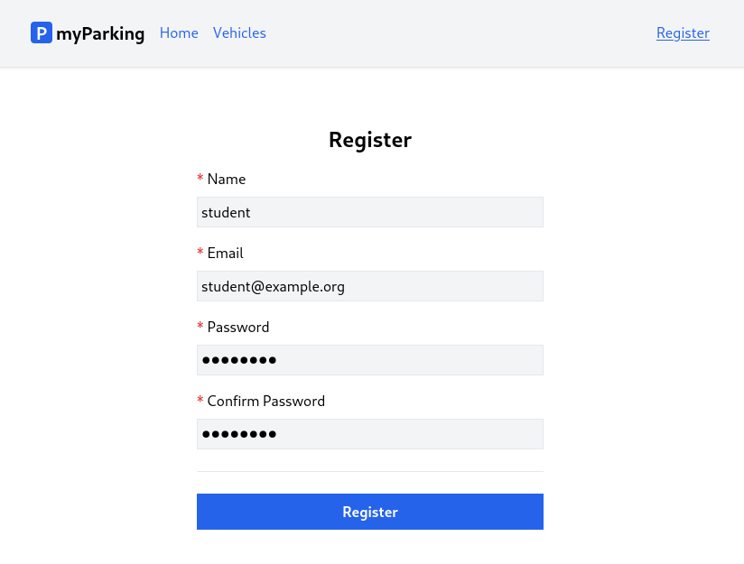
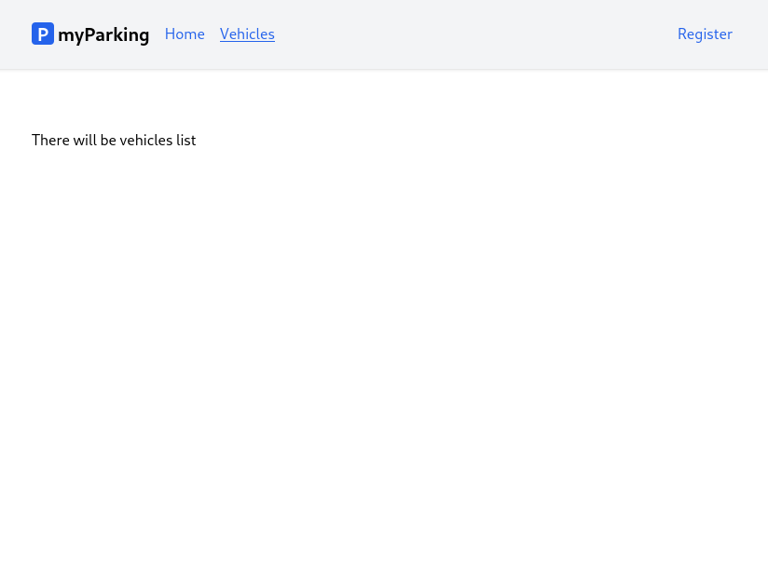
- First create a new src/views/vehicles/VehiclesList.jsx view for our future list. This is the page where the user will be redirected after registration.
function VehiclesList() {
return <div>There will be vehicles list</div>
}

export default VehiclesList
Add a new vehicles.index named route to the src/routes/index.jsx file.
const routeNames = {
'home': '/',
'register': '/register',
'vehicles.index': '/vehicles',
}
Define the new route in src/main.jsx right after the register route so the app can resolve the /vehicles path to the <VehiclesList> component.
import VehiclesList from '@/views/vehicles/VehiclesList'
<Route path={ route('register') } element={<Register />} />
<Route path={ route('vehicles.index') } element={<VehiclesList />} />
And add <NamedLink> to the vehicles.index route in the src/App.jsx file. The file now should look like this.
import { Outlet } from 'react-router-dom'
import NamedLink from '@/components/NamedLink'

function App() {
return (
<div className="App">
<header className="py-6 bg-gray-100 shadow">
<div className="container md:px-2 px-4 mx-auto">
<nav className="flex gap-4 justify-between">
<div className="flex gap-4 items-center">
<h2 className="text-xl font-bold">
<div
className="inline-flex items-center justify-center bg-blue-600 w-6 h-6 text-center text-white rounded mr-1"
>
P
</div>
myParking
</h2>
<NamedLink name="home">
Home
</NamedLink>
<NamedLink name="vehicles.index">
Vehicles
</NamedLink>
</div>
<div className="flex gap-4 items-center">
<NamedLink name="register">
Register
</NamedLink>
</div>
</nav>
</div>
</header>
<div className="container md:px-2 px-4 pt-8 md:pt-16 mx-auto">
<Outlet />
</div>
</div>
)
}

export default App
- Now to make requests from our registration form we need to install the Axios library. Run this command in your shell.
npm install axios --save
Then we need to import and configure Axios in the src/main.jsx file.
import axios from "axios";

window.axios = axios;

window.axios.defaults.headers.common["X-Requested-With"] = "XMLHttpRequest";
window.axios.defaults.withCredentials = true;
window.axios.defaults.baseURL = "http://parkingapi.test/api/v1";
We set the X-Requested-With header to tell the server it is an XHR request, and it serves an additional purpose so the server must consent to CORS policies.
Option window.axios.defaults.withCredentials = true; tells the axios library to send the cookies along the request.
The convenience option is window.axios.defaults.baseURL = "http://parkingapi.test/api/v1"; so we can omit full URLs in our requests and just type in the relative path of the server's API endpoint.
Now we have a setup for making requests to API. The content of the src/main.jsx file looks like this.
import React from 'react'
import ReactDOM from 'react-dom/client'
import { BrowserRouter, Routes, Route } from 'react-router-dom'
import axios from 'axios'
import App from '@/App'
import Home from '@/views/Home'
import Register from '@/views/auth/Register'
import VehiclesList from '@/views/vehicles/VehiclesList'
import '@/assets/main.css'
import { route } from '@/routes'

window.axios = axios
window.axios.defaults.headers.common['X-Requested-With'] = 'XMLHttpRequest'
window.axios.defaults.withCredentials = true
window.axios.defaults.baseURL = 'http://parkingapi.test/api/v1'

ReactDOM.createRoot(document.getElementById('root')).render(
<React.StrictMode>
<BrowserRouter>
<Routes>
<Route path={ route('home') } element={<App />}>
<Route index element={<Home />} />
<Route path={ route('register') } element={<Register />} />
<Route path={ route('vehicles.index') } element={<VehiclesList />} />
</Route>
</Routes>
</BrowserRouter>
</React.StrictMode>,
)
- React comes with several built-in Hooks like useState. Sometimes you'll wish that there was a Hook for some more specific purpose: for example to fetch data, hold loading state, and errors. You might not find these Hooks in React, we can create Hooks for our application's needs.
Custom hooks let us share stateful logic, but not the state itself. Components using hooks don't have as much repetitive logic. When we extract logic into custom hooks, we can hide the gnarly details of how we deal with some external system or a browser API. The components then express intent and not the implementation.
Hook names must start with use followed by a capital letter. So let's create our first hook useAuth which will implement logic related to our application's auth processes.
Create a new src/hooks/useAuth.jsx file with the following content.
import { useNavigate } from 'react-router-dom'
import { route } from '@/routes'

export function useAuth() {
const navigate = useNavigate()

async function register(data) {
return axios.post('auth/register', data)
.then(() => {
navigate(route('vehicles.index'))
})
.catch(() => {})
}

return { register }
}
Here we define the register function to make a call to http://parkingapi.test/api/v1/auth/register. Remember we don't need to define the full URL because we have baseURL set for Axios. If the request is successful then we have another hook useNavigate from React Router to navigate us to the vehicles.index route.
The useAuth() hook returns the register function, so we can use that function in our <Register> component.
- Update the src/views/auth/Register.jsx component with the following content.
import { useState } from 'react'
import { useAuth } from '@/hooks/useAuth'

function Register() {
const [name, setName] = useState('')
const [email, setEmail] = useState('')
const [password, setPassword] = useState('')
const [passwordConfirmation, setPasswordConfirmation] = useState('')
const { register } = useAuth()

async function handleSubmit(event) {
event.preventDefault()

await register({ name, email, password, password_confirmation: passwordConfirmation })

setPassword('')
setPasswordConfirmation('')
}

return (
<form onSubmit={ handleSubmit } noValidate>
<div className="flex flex-col mx-auto md:w-96 w-full">

<h1 className="heading">Register</h1>

<div className="flex flex-col gap-2 mb-4">
<label htmlFor="name" className="required">Name</label>
<input
id="name"
name="name"
type="text"
value={ name }
onChange={ event => setName(event.target.value) }
className="form-input"
autoComplete="name"
/>
</div>

<div className="flex flex-col gap-2 mb-4">
<label htmlFor="email" className="required">Email</label>
<input
id="email"
name="email"
type="email"
value={ email }
onChange={ event => setEmail(event.target.value) }
className="form-input"
autoComplete="email"
/>
</div>

<div className="flex flex-col gap-2 mb-4">
<label htmlFor="password" className="required">Password</label>
<input
id="password"
name="password"
type="password"
value={ password }
onChange={ event => setPassword(event.target.value) }
className="form-input"
autoComplete="new-password"
/>
</div>

<div className="flex flex-col gap-2">
<label htmlFor="password_confirmation" className="required">Confirm Password</label>
<input
id="password_confirmation"
name="password_confirmation"
type="password"
value={ passwordConfirmation }
onChange={ event => setPasswordConfirmation(event.target.value) }
className="form-input"
autoComplete="new-password"
/>
</div>

<div className="border-t h-[1px] my-6"></div>

<div className="flex flex-col gap-2 mb-4">
<button type="submit" className="btn btn-primary">
Register
</button>
</div>
</div>
</form>
)
}

export default Register
Here we import the useAuth hook and register function.
import { useAuth } from '@/hooks/useAuth'

// ...

const { register } = useAuth()
Then updated the handleSubmit() function to call the register function from the useAuth hook.
async function handleSubmit(event) {
event.preventDefault()

await register({ name, email, password, password_confirmation: passwordConfirmation })

setPassword('')
setPasswordConfirmation('')
}
We also added
setPassword('')
setPasswordConfirmation('')
Usually when you submit the form browser would automatically clear fields with type="password", but because we are preventing default behavior this won't happen by default and we need to do that manually to retain the same functionality. This code will be always executed disregarding if the request resulted in success or error which is the default behavior when posting forms.
After submitting the form the following response from the server will be returned:
{ access_token: "118|CJv0t9yHJcPFsifkXyoMaiCJBpRyrmsXYDLENyAN" }
And you will be redirected to the /vehicles URL, but we still have a few things missing.
- Register form has no validation if some data is incorrect and missing
- When we register we don't save the token anywhere for protected API endpoints.
Let's finish with the form first and implement validation in the next lesson.
Our objective in this lesson is to display form errors on the client side.
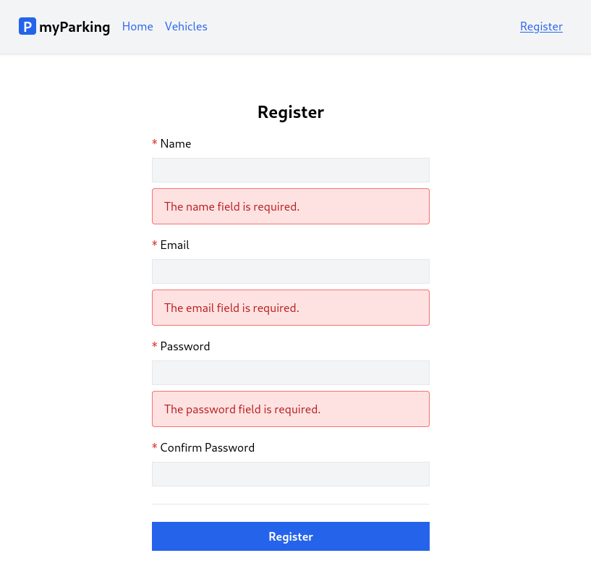
- When submitting forms it is crucial to indicate if the server doesn't accept the request and if some information provided needs to be clarified. In such cases, Laravel returns a response with more details. In our case, if we submit an empty form Laravel returns a response with a 422 status code with an object which looks like this:
{
"message": "The name field is required. (and 2 more errors)",
"errors": {
"name": [
"The name field is required."
],
"email": [
"The email field is required."
],
"password": [
"The password field is required."
]
}
}
Considering that we are going to have more forms in the future it is a good idea to have a component where we can pass errors object and a field name to display particular error messages under the specific field.
Now let's extend our useAuth hook src/hooks/useAuth.jsx by adding a new errors state, this is where we are going to store the errors object returned from the backend.
The src/hooks/useAuth.jsx file should look like this.
import { useState } from 'react'
import { useNavigate } from 'react-router-dom'
import { route } from '@/routes'

export function useAuth() {
const [errors, setErrors] = useState({})
const navigate = useNavigate()

async function register(data) {
setErrors({})

return axios.post('auth/register', data)
.then(() => {
navigate(route('vehicles.index'))
})
.catch(error => {
if (error.response.status === 422) {
setErrors(error.response.data.errors)
}
})
}

return { register, errors }
}
When the server returns error code 422 Unprocessable entity we set the errors state with the values the server returned in the catch clause.
setErrors(error.response.data.errors)
On every new submission, we want to reset the errors state, this is done with the setErrors({}) line.
- The hook has been set up and now it is a lot easier to implement the component to display error messages in form.
Create a new src/components/ValidationError.jsx component.
import PropTypes from 'prop-types'

function ValidationError({ errors, field }) {
return errors?.[field]?.length &&
<div className="alert alert-danger" role="alert">
<ul>
{ errors[field].map((error, index) => {
return (<li key={ index }>{ error }</li>)
}) }
</ul>
</div>
}

ValidationError.propTypes = {
errors: PropTypes.object.isRequired,
field: PropTypes.string.isRequired,
}

export default ValidationError
Like we did with the NamedLink component, we define properties errors and field that component will accept and display errors for a field where the object key matches.
- Now we can update our src/views/auth/Register.jsx component. To display error messages is pretty straightforward now.
import { useState } from 'react'
import { useAuth } from '@/hooks/useAuth'
import ValidationError from '@/components/ValidationError'

function Register() {
const [name, setName] = useState('')
const [email, setEmail] = useState('')
const [password, setPassword] = useState('')
const [passwordConfirmation, setPasswordConfirmation] = useState('')
const { register, errors } = useAuth()

async function handleSubmit(event) {
event.preventDefault()

await register({ name, email, password, password_confirmation: passwordConfirmation })

setPassword('')
setPasswordConfirmation('')
}

return (
<form onSubmit={ handleSubmit } noValidate>
<div className="flex flex-col mx-auto md:w-96 w-full">

<h1 className="heading">Register</h1>

<div className="flex flex-col gap-2 mb-4">
<label htmlFor="name" className="required">Name</label>
<input
id="name"
name="name"
type="text"
value={ name }
onChange={ event => setName(event.target.value) }
className="form-input"
autoComplete="name"
/>
<ValidationError errors={ errors } field="name" />
</div>

<div className="flex flex-col gap-2 mb-4">
<label htmlFor="email" className="required">Email</label>
<input
id="email"
name="email"
type="email"
value={ email }
onChange={ event => setEmail(event.target.value) }
className="form-input"
autoComplete="email"
/>
<ValidationError errors={ errors } field="email" />
</div>

<div className="flex flex-col gap-2 mb-4">
<label htmlFor="password" className="required">Password</label>
<input
id="password"
name="password"
type="password"
value={ password }
onChange={ event => setPassword(event.target.value) }
className="form-input"
autoComplete="new-password"
/>
<ValidationError errors={ errors } field="password" />
</div>

<div className="flex flex-col gap-2">
<label htmlFor="password_confirmation" className="required">Confirm Password</label>
<input
id="password_confirmation"
name="password_confirmation"
type="password"
value={ passwordConfirmation }
onChange={ event => setPasswordConfirmation(event.target.value) }
className="form-input"
autoComplete="new-password"
/>
</div>

<div className="border-t h-[1px] my-6"></div>

<div className="flex flex-col gap-2 mb-4">
<button type="submit" className="btn btn-primary">
Register
</button>
</div>
</div>
</form>
)
}

export default Register
Here we imported the ValidationError component.
import ValidationError from '@/components/ValidationError'
Unpacked errors state from useAuth hook.
const { register, errors } = useAuth()
And added the ValidationError component after each input value by passing the errors state and field name which matches keys from the API response.
<ValidationError errors={ errors } field="name" />
<ValidationError errors={ errors } field="email" />
<ValidationError errors={ errors } field="password" />
password_confirmation field never returns error messages, so we do not need to add it there. Password-related errors are always returned under the password key.
In this lesson, when a user submits the form, we are going to indicate if the form is being processed to give the user some feedback to have a more pleasant user experience.
Before submit:
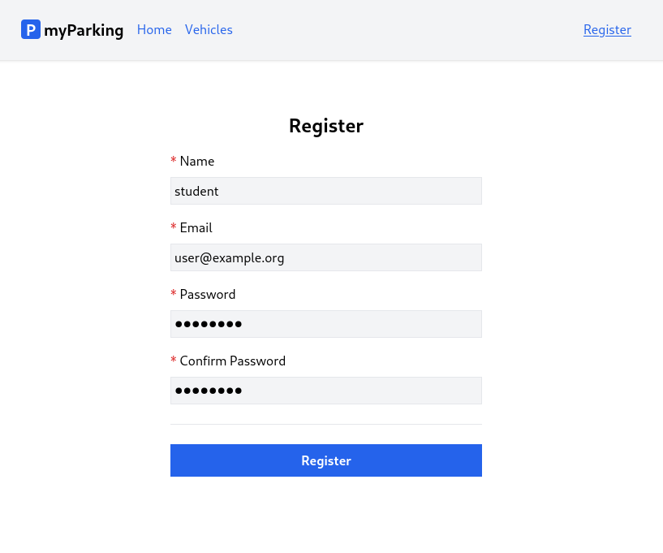
Right after the form is submitted and the client waits for a response:
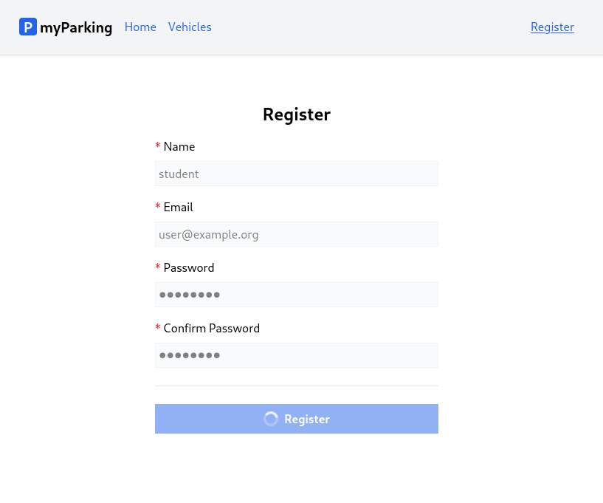
- By looking at the result we can immediately see that there is a new thing in the form, it is a loading indicator on the button.
Create a new component src/components/IconSpinner.jsx with the following content.
function IconSpinner() {
return <svg
className="animate-spin h-5 w-5 text-white"
xmlns="http://www.w3.org/2000/svg"
fill="none"
viewBox="0 0 24 24"
>
<circle
className="opacity-25"
cx="12"
cy="12"
r="10"
stroke="currentColor"
strokeWidth="4"
></circle>
<path
className="opacity-75"
fill="currentColor"
d="M4 12a8 8 0 018-8V0C5.373 0 0 5.373 0 12h4zm2 5.291A7.962 7.962 0 014 12H0c0 3.042 1.135 5.824 3 7.938l3-2.647z"
></path>
</svg>
}

export default IconSpinner
This component consists of an SVG icon and some TailwindCSS classes. animate-spin class applies persistent rotation animation on the icon.
- Let's update the src/hooks/useAuth.jsx hook by adding a loading state.
import { useState } from 'react'
import { useNavigate } from 'react-router-dom'
import { route } from '@/routes'

export function useAuth() {
const [errors, setErrors] = useState({})
const [loading, setLoading] = useState(false)
const navigate = useNavigate()

async function register(data) {
setErrors({})
setLoading(true)

return axios.post('auth/register', data)
.then(() => {
navigate(route('vehicles.index'))
})
.catch(error => {
if (error.response.status === 422) {
setErrors(error.response.data.errors)
}
})
.finally(() => setLoading(false))
}

return { register, errors, loading }
}
At the beginning of the register function, we call setLoading(true) to update the state. In the finally() block we set the loading state back to false. finally() will be called always, even if the request failed.
And added loading to the return statement.
- Now we can do the final changes to the src/views/auth/Register.jsx component.
Import the IconSpinner component.
import IconSpinner from '@/components/IconSpinner'
Unpack the loading state from the useAuth hook.
const { register, errors, loading } = useAuth()
Add disabled property to every input field.
<input
// ...
disabled={ loading }
/>
The disabled property will be applied to input tags only if the loading state evaluates to true.
Also, update the button.
<button type="submit" className="btn btn-primary" disabled={ loading }>
{ loading && <IconSpinner /> }
Register
</button>
Your components will often need to display different things depending on different conditions. In our case to display IconSpinner only when the loading state is true, we can use AND operator &&. This is a common shortcut inside React components, it often comes up when you want to render some JSX when the condition is true, or render nothing otherwise.
Currently our Register component src/views/auth/Register.jsx should look like this.
import { useState } from 'react'
import { useAuth } from '@/hooks/useAuth'
import ValidationError from '@/components/ValidationError'
import IconSpinner from '@/components/IconSpinner'

function Register() {
const [name, setName] = useState('')
const [email, setEmail] = useState('')
const [password, setPassword] = useState('')
const [passwordConfirmation, setPasswordConfirmation] = useState('')
const { register, errors, loading } = useAuth()

async function handleSubmit(event) {
event.preventDefault()

await register({ name, email, password, password_confirmation: passwordConfirmation })

setPassword('')
setPasswordConfirmation('')
}

return (
<form onSubmit={ handleSubmit } noValidate>
<div className="flex flex-col mx-auto md:w-96 w-full">

<h1 className="heading">Register</h1>

<div className="flex flex-col gap-2 mb-4">
<label htmlFor="name" className="required">Name</label>
<input
id="name"
name="name"
type="text"
value={ name }
onChange={ event => setName(event.target.value) }
className="form-input"
autoComplete="name"
disabled={ loading }
/>
<ValidationError errors={ errors } field="name" />
</div>

<div className="flex flex-col gap-2 mb-4">
<label htmlFor="email" className="required">Email</label>
<input
id="email"
name="email"
type="email"
value={ email }
onChange={ event => setEmail(event.target.value) }
className="form-input"
autoComplete="email"
disabled={ loading }
/>
<ValidationError errors={ errors } field="email" />
</div>

<div className="flex flex-col gap-2 mb-4">
<label htmlFor="password" className="required">Password</label>
<input
id="password"
name="password"
type="password"
value={ password }
onChange={ event => setPassword(event.target.value) }
className="form-input"
autoComplete="new-password"
disabled={ loading }
/>
<ValidationError errors={ errors } field="password" />
</div>

<div className="flex flex-col gap-2">
<label htmlFor="password_confirmation" className="required">Confirm Password</label>
<input
id="password_confirmation"
name="password_confirmation"
type="password"
value={ passwordConfirmation }
onChange={ event => setPasswordConfirmation(event.target.value) }
className="form-input"
autoComplete="new-password"
disabled={ loading }
/>
</div>

<div className="border-t h-[1px] my-6"></div>

<div className="flex flex-col gap-2 mb-4">
<button type="submit" className="btn btn-primary" disabled={ loading }>
{ loading && <IconSpinner /> }
Register
</button>
</div>
</div>
</form>
)
}

export default Register

Q: I submit the registration form but can't see the loading state, what to do?

A:
This is normal especially if you work in the local environment, there are several options to trigger the loading state, the easiest ones are:
- You can just change the const [loading, setLoading] = useState(false) default value from false to true and refresh the page. Your form immediately will be in a loading state.
- To imitate network latency you can add sleep(3) at the beginning of your API RegisterController to delay the response for 3 seconds. Only if you're working locally and do not forget to remove it.
Congratulations, now you know how to implement the most commonly used practices using forms.
Let's dive into authentication scaffolding.
In this lesson, we will focus on implementing authentication, which is a crucial aspect for our client. Our objectives are as follows:
- Upon successful registration, the client will save the token to the local storage.
- When the logout button is pressed while the user is logged in, the access token will be removed, and the user will be redirected to the login template. We will implement the login page itself in the next lesson.
- The navigation links will be displayed or hidden based on the user's login status.
- If a request fails with a 401 Unauthenticated response, the user will be redirected to the login page.
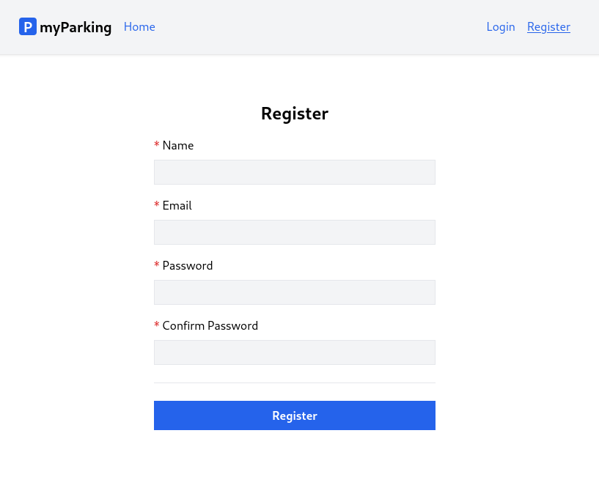
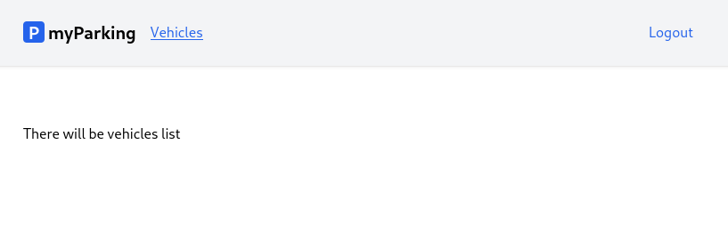
- Create a new dummy component src/views/auth/Login.jsx.
function Login() {
return <div>There will be login form</div>
}

export default Login
- Declare the named route to the login page in src/routes/index.jsx. We chose to put it after the register route.
const routeNames = {
'home': '/',
'register': '/register',
'login': '/login',
'vehicles.index': '/vehicles',
}
All content of src/routes/index.jsx looks like that.
const routeNames = {
'home': '/',
'register': '/register',
'login': '/login',
'vehicles.index': '/vehicles',
}

function route(name, params = {}) {
let url = routeNames[name]

for (let prop in params) {
if (Object.prototype.hasOwnProperty.call(params, prop)) {
url = url.replace(`:${prop}`, params[prop])
}
}

return url
}

export { route }
- Import the login component and define the route in the src/main.jsx file.
import Login from '@/views/auth/Login'
<Route path={ route('login') } element={<Login />} />
src/main.jsx has the following content.
import React from 'react'
import ReactDOM from 'react-dom/client'
import { BrowserRouter, Routes, Route } from 'react-router-dom'
import axios from 'axios'
import App from '@/App'
import Home from '@/views/Home'
import Register from '@/views/auth/Register'
import Login from '@/views/auth/Login'
import VehiclesList from '@/views/vehicles/VehiclesList'
import '@/assets/main.css'
import { route } from '@/routes'

window.axios = axios
window.axios.defaults.headers.common['X-Requested-With'] = 'XMLHttpRequest'
window.axios.defaults.withCredentials = true
window.axios.defaults.baseURL = 'http://parkingapi.test/api/v1'

ReactDOM.createRoot(document.getElementById('root')).render(
<React.StrictMode>
<BrowserRouter>
<Routes>
<Route path={ route('home') } element={<App />}>
<Route index element={<Home />} />
<Route path={ route('register') } element={<Register />} />
<Route path={ route('login') } element={<Login />} />
<Route path={ route('vehicles.index') } element={<VehiclesList />} />
</Route>
</Routes>
</BrowserRouter>
</React.StrictMode>,
)
- To work with localStorage we are going to need the react-use-storage package to store the token in the client application.
Enter the following command in your shell.
npm install react-use-storage --save
- Update the src/hooks/useAuth.jsx hook with the following content.
import { useState, useMemo, useEffect } from 'react'
import { useNavigate } from 'react-router-dom'
import { useLocalStorage } from 'react-use-storage'
import { route } from '@/routes'

export function useAuth() {
const [errors, setErrors] = useState({})
const [loading, setLoading] = useState(false)
const [accessToken, setAccessToken, removeAccessToken] = useLocalStorage('access_token', '')

const navigate = useNavigate()

const isLoggedIn = useMemo(() => !!accessToken, [accessToken])

useEffect(() => {
if (accessToken) {
axios.defaults.headers.common['Authorization'] = `Bearer ${accessToken}`
}
}, [accessToken])

async function register(data) {
setErrors({})
setLoading(true)

return axios.post('auth/register', data)
.then((response) => {
setAccessToken(response.data.access_token)
navigate(route('vehicles.index'))
})
.catch(error => {
if (error.response.status === 422) {
setErrors(error.response.data.errors)
}
})
.finally(() => setLoading(false))
}

async function logout(force = false) {
if (!force) {
await axios.post('auth/logout')
}

removeAccessToken()
navigate(route('login'))
}

return { register, errors, loading, isLoggedIn, logout }
}
Now we will go through what is new in this hook.

Local Storage
We imported the useLocalStorage hook from the react-use-storage package.
import { useLocalStorage } from 'react-use-storage'
Then we can define a new state variable accessToken and two more methods to manage that state, setAccessToken along with removeAccessToken. This is different from useState because it is persistent in the browser's localStorage, and the value is kept even if you close the browser tab.
const [accessToken, setAccessToken, removeAccessToken] = useLocalStorage('access_token', '')
In the register() function we save the access token from the response to localStorage by calling setAccessToken().
.then((response) => {
setAccessToken(response.data.access_token)
navigate(route('vehicles.index'))
})

Side effects and Authorization header update
When the token is stored, we have a side effect, which means we want to update the Authorization header for axios so our requests now can call protected API routes. This is done with an imported useEffect() hook from react.
useEffect(() => {
if (accessToken) {
axios.defaults.headers.common['Authorization'] = `Bearer ${accessToken}`
}
}, [accessToken])
useEffect is a React Hook that lets you synchronize a component with an external system when you need to "step out" of your React code. This includes browser APIs, third-party widgets, networks, and so on.
It accepts two parameters useEffect(setup, dependencies?).
- setup: The function with your Effect’s logic. Your setup function may also optionally return a cleanup function. When your component is first added to the DOM, React will run your setup function. After every re-render with changed dependencies, React will first run the cleanup function (if you provided it) with the old values, and then run your setup function with the new values. After your component is removed from the DOM, React will run your cleanup function one last time.
- optional dependencies: The list of all reactive values referenced inside of the setup code. Reactive values include props, state, and all the variables and functions declared directly inside your component body. If your linter is configured for React, it will verify that every reactive value is correctly specified as a dependency. The list of dependencies must have a constant number of items and be written inline like [dep1, dep2, dep3]. React will compare each dependency with its previous value using the Object.is comparison algorithm. If you don’t specify the dependencies at all, your Effect will re-run after every re-render of the component. See the difference between passing an array of dependencies, an empty array, and no dependencies at all.
useEffect(() => {
// This runs after every render
});

useEffect(() => {
// This runs only on mount (when the component appears)
}, []);

useEffect(() => {
// This runs on mount *and also* if either a or b have changed since the last render
}, [a, b]);
More information and examples can be found in official React documentation:
- useEffect
- Synchronizing with Effects
- You Might Not Need an Effect
So we have declared accessToken as our dependency, and if it evaluates to true, Axios Authorization header will be updated for future requests.

Auth status and memoization
To display and hide navigation links we need to know if a user is logged in. We decide that depending if the token present evaluates to true.
const isLoggedIn = useMemo(() => !!accessToken, [accessToken])
For this purpose, we use the useMemo hook, which lets us cache the result of the calculation. The value returned by the anonymous function passed to useMemo is memoized and React returns the same value between rerenders if dependencies declared in the array as a second argument have not changed. It will be updated only if the token value changes.
More information on useMemo can be found here:
- useMemo
The last function declared is logout. A request to delete the current token in use from the server will be sent. Then the token is removed from the client itself, and the user is redirected to the login page.
async function logout(force = false) {
if (!force) {
await axios.post('auth/logout')
}

removeAccessToken()
navigate(route('login'))
}
If Axios request fails with 401 Unauthenticated error, we call this function with force flag, which means the token is already invalid and we do not need to send that request, otherwise, we will be caught in an infinite loop.
Finally, isLoggedIn and logout are added to the return statement.
return { register, errors, loading, isLoggedIn, logout }
- Update the src/App.jsx component with the following content.
import { Outlet } from 'react-router-dom'
import NamedLink from '@/components/NamedLink'
import { useAuth } from '@/hooks/useAuth'

function App() {
const { isLoggedIn, logout } = useAuth()

axios.interceptors.response.use(
response => response,
error => {
if (error.response?.status === 401) logout(true)
return Promise.reject(error)
},
)

function leftGuestLinks() {
return <>
<NamedLink name="home">
Home
</NamedLink>
</>
}

function leftAuthLinks() {
return <>
<NamedLink name="vehicles.index">
Vehicles
</NamedLink>
</>
}

function rightGuestLinks() {
return <>
<NamedLink name="login">
Login
</NamedLink>
<NamedLink name="register">
Register
</NamedLink>
</>
}

function rightAuthLinks() {
return <>
<button onClick={ logout } type="button" className="text-blue-600">
Logout
</button>
</>
}

return (
<div className="App">
<header className="py-6 bg-gray-100 shadow">
<div className="container md:px-2 px-4 mx-auto">
<nav className="flex gap-4 justify-between">
<div className="flex gap-4 items-center">
<h2 className="text-xl font-bold">
<div
className="inline-flex items-center justify-center bg-blue-600 w-6 h-6 text-center text-white rounded mr-1"
>
P
</div>
myParking
</h2>
{ isLoggedIn ? leftAuthLinks() : leftGuestLinks() }
</div>
<div className="flex gap-4 items-center">
{ isLoggedIn ? rightAuthLinks() : rightGuestLinks() }
</div>
</nav>
</div>
</header>
<div className="container md:px-2 px-4 pt-8 md:pt-16 mx-auto">
<Outlet />
</div>
</div>
)
}

export default App
Here we import useAuth in our main src/App.jsx app layout to be able to display/hide menu items and logout.
import { useAuth } from '@/hooks/useAuth'

// ...

const { isLoggedIn, logout } = useAuth()

Axios interceptor
To intercept every response received by the Axios library we need to define an interceptor. If the request was unauthenticated it will call the logout function. The access token will be destroyed and the user will see a login page.
axios.interceptors.response.use(
response => response,
error => {
if (error.response?.status === 401) logout(true)
return Promise.reject(error)
},
)

Display/hide links
In JSX we can use conditional rendering using ternary operators ? :. To make code more readable we have put navigation links into separate render functions.
{ isLoggedIn ? leftAuthLinks() : leftGuestLinks() }
// ...
{ isLoggedIn ? rightAuthLinks() : rightGuestLinks() }
In our case, one of the functions looks like this.
function rightGuestLinks() {
return <>
<NamedLink name="login">
Login
</NamedLink>
<NamedLink name="register">
Register
</NamedLink>
</>
}
The return statement of a component must always consist of a single element. Due to this limitation, whenever multiple elements need to be returned from a component, a wrapper element must be created. This is where React Fragment comes in. You can see them as empty tags <> </>.
With React Fragments, the extra wrapper element that was previously required to render multiple elements from a component can be eliminated. This allows multiple elements to be returned without being contained in a wrapper element.

Logout button
In the rightAuthLinks function, we have a button with an onClick handler to call the logout function.
function rightAuthLinks() {
return <>
<button onClick={ logout } type="button" className="text-blue-600">
Logout
</button>
</>
}
Now you have implemented Authentication on your app.
Developing a login page has become a straightforward task, as we have already established all the necessary features for our application. It will closely resemble the registration page.
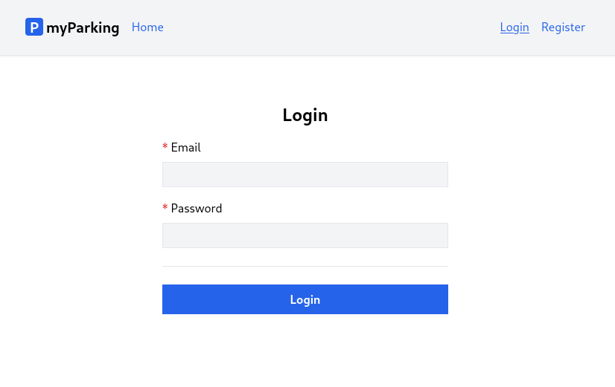
When a user logs in we want him to be redirected to the active parking list, so let's create a new empty component for this purpose, we will implement the active parking list later.
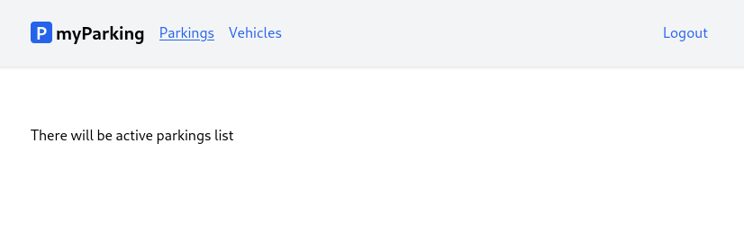
- Create a new src/views/parkings/ActiveParkings.jsx component.
function ActiveParkings() {
return <div>There will be active parkings list</div>
}

export default ActiveParkings
- Add a new named route 'parkings.active': '/parkings/active' to the src/routes/index.jsx file.
const routeNames = {
'home': '/',
'register': '/register',
'login': '/login',
'vehicles.index': '/vehicles',
'parkings.active': '/parkings/active',
}
- Define a new route for React Router in the src/main.jsx file.
import ActiveParkings from '@/views/parkings/ActiveParkings'
<Route path={ route('parkings.active') } element={<ActiveParkings />} />
The src/main.jsx file now should look like this.
import React from 'react'
import ReactDOM from 'react-dom/client'
import { BrowserRouter, Routes, Route } from 'react-router-dom'
import axios from 'axios'
import App from '@/App'
import Home from '@/views/Home'
import Register from '@/views/auth/Register'
import Login from '@/views/auth/Login'
import VehiclesList from '@/views/vehicles/VehiclesList'
import ActiveParkings from '@/views/parkings/ActiveParkings'
import '@/assets/main.css'
import { route } from '@/routes'

window.axios = axios
window.axios.defaults.headers.common['X-Requested-With'] = 'XMLHttpRequest'
window.axios.defaults.withCredentials = true
window.axios.defaults.baseURL = 'http://parkingapi.test/api/v1'

ReactDOM.createRoot(document.getElementById('root')).render(
<React.StrictMode>
<BrowserRouter>
<Routes>
<Route path={ route('home') } element={<App />}>
<Route index element={<Home />} />
<Route path={ route('register') } element={<Register />} />
<Route path={ route('login') } element={<Login />} />
<Route path={ route('vehicles.index') } element={<VehiclesList />} />
<Route path={ route('parkings.active') } element={<ActiveParkings />} />
</Route>
</Routes>
</BrowserRouter>
</React.StrictMode>,
)
- Update the leftAuthLinks function in the src/App.jsx function by adding a navigation link to the parkings.active route for authenticated users before vehicles.index.
function leftAuthLinks() {
return <>
<NamedLink name="parkings.active">
Parkings
</NamedLink>
<NamedLink name="vehicles.index">
Vehicles
</NamedLink>
</>
}
- Extend the src/hooks/useAuth.jsx hook by adding a new function to send login requests.
async function login(data) {
setErrors({})
setLoading(true)

return axios.post('/auth/login', data)
.then(response => {
setAccessToken(response.data.access_token)
navigate(route('parkings.active'))
})
.catch(error => {
if (error.response.status === 422) {
setErrors(error.response.data.errors)
}
})
.finally(() => setLoading(false))
}
It is almost identical to the register function, and the structure was explained in previous lessons. Now it has a different axios.post() URL.
And add it to the return statement.
return { register, login, errors, loading, isLoggedIn, logout }
The src/hooks/useAuth.jsx file now should have the following content.
import { useState, useMemo, useEffect } from 'react'
import { useNavigate } from 'react-router-dom'
import { useLocalStorage } from 'react-use-storage'
import { route } from '@/routes'

export function useAuth() {
const [errors, setErrors] = useState({})
const [loading, setLoading] = useState(false)
const [accessToken, setAccessToken, removeAccessToken] = useLocalStorage('access_token', '')

const navigate = useNavigate()

const isLoggedIn = useMemo(() => !!accessToken, [accessToken])

useEffect(() => {
if (accessToken) {
axios.defaults.headers.common['Authorization'] = `Bearer ${accessToken}`
}
}, [accessToken])

async function register(data) {
setErrors({})
setLoading(true)

return axios.post('auth/register', data)
.then((response) => {
setAccessToken(response.data.access_token)
navigate(route('vehicles.index'))
})
.catch(error => {
if (error.response.status === 422) {
setErrors(error.response.data.errors)
}
})
.finally(() => setLoading(false))
}

async function login(data) {
setErrors({})
setLoading(true)

return axios.post('/auth/login', data)
.then(response => {
setAccessToken(response.data.access_token)
navigate(route('parkings.active'))
})
.catch(error => {
if (error.response.status === 422) {
setErrors(error.response.data.errors)
}
})
.finally(() => setLoading(false))
}

async function logout(force = false) {
if (!force) {
await axios.post('auth/logout')
}

removeAccessToken()
navigate(route('login'))
}

return { register, login, errors, loading, isLoggedIn, logout }
}
- Update the src/views/auth/Login.jsx component with the following content.
import { useState } from 'react'
import { useAuth } from '@/hooks/useAuth'
import ValidationError from '@/components/ValidationError'
import IconSpinner from '@/components/IconSpinner'

function Login() {
const [email, setEmail] = useState('')
const [password, setPassword] = useState('')
const [remember, setRemember] = useState(false)
const { login, errors, loading } = useAuth()

async function handleSubmit(event) {
event.preventDefault()

await login({ email, password })

setPassword('')
}

return (
<form onSubmit={ handleSubmit } noValidate>
<div className="flex flex-col mx-auto md:w-96 w-full">
<h1 className="heading">Login</h1>
<div className="flex flex-col gap-2 mb-4">
<label htmlFor="email" className="required">Email</label>
<input
id="email"
name="email"
type="text"
value={ email }
onChange={ event => setEmail(event.target.value) }
className="form-input"
autoComplete="email"
disabled={ loading }
/>
<ValidationError errors={ errors } field="email" />
</div>

<div className="flex flex-col gap-2 mb-4">
<label htmlFor="password" className="required">Password</label>
<input
id="password"
name="password"
type="password"
value={ password }
onChange={ event => setPassword(event.target.value) }
className="form-input"
autoComplete="current-password"
disabled={ loading }
/>
<ValidationError errors={ errors } field="password" />
</div>

<div className="flex flex-col gap-2">
<label className="flex gap-2 items-center hover:cursor-pointer" htmlFor="remember">
<input
id="remember"
name="remember"
type="checkbox"
className="w-4 h-4"
checked={ remember }
onChange={ () => setRemember((previous) => !previous) }
disabled={ loading }
/>
<span className="select-none">Remember me</span>
</label>
</div>

<div className="border-t h-[1px] my-6"></div>

<div className="flex flex-col gap-2 mb-4">
<button type="submit" className="btn btn-primary" disabled={ loading }>
{ loading && <IconSpinner /> }
Login
</button>
</div>
</div>
</form>
)
}

export default Login
Here we have a new state variable for Remember me checkbox. It has a boolean value to determine checkbox is marked or not.
const [remember, setRemember] = useState(false)
The checkbox itself is defined like this:
<input
id="remember"
name="remember"
type="checkbox"
className="w-4 h-4"
checked={ remember }
onChange={ () => setRemember((previous) => !previous) }
disabled={ loading }
/>
This time we bind the value to the checked attribute and the checkbox will be marked as checked if the remember variable evaluates to true.
When updating the state value using the setRemember function, it can accept the setter function with a previous value as an argument, then we just invert the boolean value using !previous.
onChange={ () => setRemember((previous) => !previous) }
There is no need to redo any validation or loading state work, simply adjust the value of the field property in the ValidationError component to match the fields in the login form received from the API.

Let's keep building the client software by adding more functionality. In this lesson, we'll learn how to retrieve profile information and create a form for updating your profile details like your name and email.
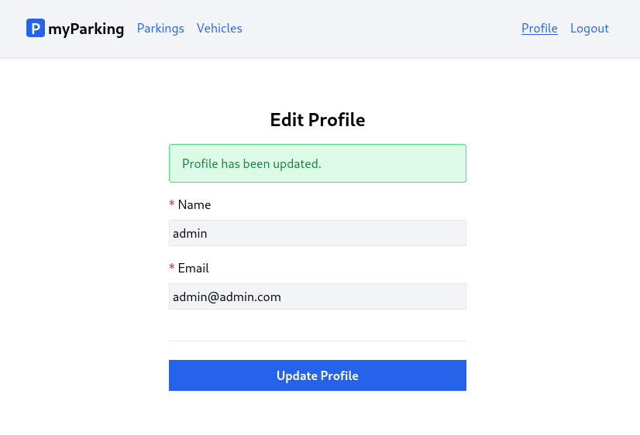
- First let's write our logic for a profile that we can later use in the profile view. Create a new src/hooks/useProfile.jsx hook with the following content.
import { useState, useEffect } from 'react'

export function useProfile() {
const [errors, setErrors] = useState({})
const [loading, setLoading] = useState(false)
const [status, setStatus] = useState('')
const [data, setData] = useState({})

useEffect(() => {
const controller = new AbortController()
getProfile({ signal: controller.signal })
return () => controller.abort()
}, [])

async function getProfile({ signal } = {}) {
setLoading(true)

return axios.get('profile', { signal })
.then(response => setData(response.data))
.catch(() => {})
.finally(() => setLoading(false))
}

async function updateProfile(data) {
setLoading(true)
setErrors({})
setStatus('')

return axios.put('profile', data)
.then(() => {
setStatus('Profile has been updated.')
})
.catch(error => {
if (error.response.status === 422) {
setErrors(error.response.data.errors)
}
})
.finally(() => setLoading(false))
}

return [{ data, setData, errors, loading, status }, updateProfile]
}
It has a similar structure to useAuth with errors and loading states. To fetch user profile data we have the getProfile function.
async function getProfile({ signal } = {}) {
setLoading(true)

return axios.get('profile', { signal })
.then(response => setData(response.data))
.catch(() => {})
.finally(() => setLoading(false))
}
Response with profile data will be stored in the data state variable.
useEffect(() => {
const controller = new AbortController()
getProfile({ signal: controller.signal })
return () => controller.abort()
}, [])
To fetch data automatically on render useEffect comes in handy. But what is that abort controller?
The AbortController is a JavaScript API that allows you to signal to a fetch operation that you want to abort it. It provides a way to cancel a fetch operation before it completes, which can be useful in a variety of situations, such as when you're loading data from a remote server and the user navigates away from the page, or when a network request takes too long to complete.
An instance of AbortController is created using the new AbortController() constructor, and it exposes an abort() method that can be used to cancel the associated fetch operation. The AbortController also has a property signal which is an AbortSignal object that represents the signal to abort the operation.
Here's an example of how you might use the AbortController in a fetch operation:
const controller = new AbortController();
const signal = controller.signal;

fetch('https://api.example.com/data', { signal })
.then(response => {
// Handle the response data
})
.catch(error => {
if (error.name === 'AbortError') {
// Handle the abort error
} else {
// Handle other errors
}
});

// Later, if you want to cancel the fetch operation:
controller.abort();
Note that the AbortController API is relatively new and is not yet supported by all browsers, so you might need to use a polyfill or check for support before using it in your code.
So in our use case, the Axios library does accept that abort signal so we pass it to the getProfile function. It is useful when useEffect is triggered more than once, so previous requests will be aborted. That way we can avoid race conditions in this scenario:
1st request - takes 150ms
2nd request - takes 50ms
3rd request - takes 100ms
Without AbortController we can end up in a situation where we have data not from the latest request because 1st request finished last, and the data we got from 2nd and 3rd requests will be overwritten with the older one.
The useEffect hook returns a cleanup function that is called when the component that uses the hook is unmounted or when the effect is re-run with different dependencies. The cleanup function allows you to undo the changes made in the effect.
In our case we cancel the previous request like that:
return () => controller.abort()
Note that this time we also have a bit different return statement:
return [{ data, setData, errors, loading, status }, updateProfile]
This time we return an array instead of an object, this is useful when don't want to unpack every single value. And now it can be used like this:
const [profile, updateProfile] = useProfile()
Profile data, errors, and loading state now can be accessed like this profile.data, profile.errors, etc. Very similar to useState in some way, except it wraps a lot more logic for our application.
One more new thing we have here is the state variable status:
const [status, setStatus] = useState('')
It will be used to display a success message after successfully updating profile information by calling setStatus in the updateProfile function:
setStatus('Profile has been updated.')
- Create a new src/views/profile/EditProfile.jsx component with the following content.
import { useProfile } from '@/hooks/useProfile'
import ValidationError from '@/components/ValidationError'
import IconSpinner from '@/components/IconSpinner'

function EditProfile() {
const [profile, updateProfile] = useProfile()

async function handleSubmit(event) {
event.preventDefault()
await updateProfile(profile.data)
}

return (
<form onSubmit={ handleSubmit }>
<div className="flex flex-col mx-auto md:w-96 w-full">
<h1 className="heading">Edit Profile</h1>

{ profile.status &&
<div className="alert alert-success mb-4" role="alert">
{ profile.status }
</div>
}

<div className="flex flex-col gap-2 mb-4">
<label htmlFor="name" className="required">Name</label>
<input
id="name"
name="name"
type="text"
value={ profile.data.name ?? '' }
onChange={ event => profile.setData({ ...profile.data, name: event.target.value }) }
className="form-input"
autoComplete="name"
disabled={ profile.loading }
/>
<ValidationError errors={ profile.errors } field="name" />
</div>

<div className="flex flex-col gap-2 mb-4">
<label htmlFor="email" className="required">Email</label>
<input
id="email"
name="email"
type="email"
value={ profile.data.email ?? '' }
onChange={ event => profile.setData({ ...profile.data, email: event.target.value }) }
className="form-input"
autoComplete="email"
disabled={ profile.loading }
/>
<ValidationError errors={ profile.errors } field="email" />
</div>

<div className="border-t h-[1px] my-6"></div>

<div className="flex flex-col gap-2 mb-4">
<button type="submit" className="btn btn-primary" disabled={ profile.loading }>
{ profile.loading && <IconSpinner /> }
Update Profile
</button>
</div>

</div>
</form>
)
}

export default EditProfile
Now as mentioned before, we can consume the useProfile hook like this:
const [profile, updateProfile] = useProfile()
Note that this time we have different value properties and onChange handlers on input fields.
While there is no data fetched yet, we can use the null coalescing operator to avoid ... is undefined errors. This value will be updated automatically once the request is resolved.
value={ profile.data.name ?? '' }
To update the profile we call the profile.setData function, and pass a new object unpacking all profile data using ...profile.data and overwriting the key with the new value name: event.target.value. It is important to unpack first.
onChange={ event => profile.setData({ ...profile.data, name: event.target.value }) }
A success message is displayed by using the same logic we used for IconSpinner, if the expression on the left evaluates to true then content after AND && operator will be rendered, otherwise, it will render nothing.
{ profile.status &&
<div className="alert alert-success mb-4" role="alert">
{ profile.status }
</div>
}
- Update named routes in the src/routes/index.jsx file. The full content of this file now looks as follows.
const routeNames = {
'home': '/',
'register': '/register',
'login': '/login',
'profile.edit': '/profile',
'vehicles.index': '/vehicles',
'parkings.active': '/parkings/active',
}

function route(name, params = {}) {
let url = routeNames[name]

for (let prop in params) {
if (Object.prototype.hasOwnProperty.call(params, prop)) {
url = url.replace(`:${prop}`, params[prop])
}
}

return url
}

export { route }
- Define the component with the profile.edit route in src/main.jsx. The full file should have the following content.
import React from 'react'
import ReactDOM from 'react-dom/client'
import { BrowserRouter, Routes, Route } from 'react-router-dom'
import axios from 'axios'
import App from '@/App'
import Home from '@/views/Home'
import Register from '@/views/auth/Register'
import Login from '@/views/auth/Login'
import EditProfile from '@/views/profile/EditProfile'
import VehiclesList from '@/views/vehicles/VehiclesList'
import ActiveParkings from '@/views/parkings/ActiveParkings'
import '@/assets/main.css'
import { route } from '@/routes'

window.axios = axios
window.axios.defaults.headers.common['X-Requested-With'] = 'XMLHttpRequest'
window.axios.defaults.withCredentials = true
window.axios.defaults.baseURL = 'http://parkingapi.test/api/v1'

ReactDOM.createRoot(document.getElementById('root')).render(
<React.StrictMode>
<BrowserRouter>
<Routes>
<Route path={ route('home') } element={<App />}>
<Route index element={<Home />} />
<Route path={ route('register') } element={<Register />} />
<Route path={ route('login') } element={<Login />} />
<Route path={ route('profile.edit') } element={<EditProfile />} />
<Route path={ route('vehicles.index') } element={<VehiclesList />} />
<Route path={ route('parkings.active') } element={<ActiveParkings />} />
</Route>
</Routes>
</BrowserRouter>
</React.StrictMode>,
)
- And finally add a link to the profile edit component in the rightAuthLinks function on the src/App.jsx file. The file should have the following content.
import { Outlet } from 'react-router-dom'
import NamedLink from '@/components/NamedLink'
import { useAuth } from '@/hooks/useAuth'

function App() {
const { isLoggedIn, logout } = useAuth()

axios.interceptors.response.use(
response => response,
error => {
if (error.response?.status === 401) logout(true)
return Promise.reject(error)
},
)

function leftGuestLinks() {
return <>
<NamedLink name="home">
Home
</NamedLink>
</>
}

function leftAuthLinks() {
return <>
<NamedLink name="parkings.active">
Parkings
</NamedLink>
<NamedLink name="vehicles.index">
Vehicles
</NamedLink>
</>
}

function rightGuestLinks() {
return <>
<NamedLink name="login">
Login
</NamedLink>
<NamedLink name="register">
Register
</NamedLink>
</>
}

function rightAuthLinks() {
return <>
<NamedLink name="profile.edit">
Profile
</NamedLink>
<button onClick={ logout } type="button" className="text-blue-600">
Logout
</button>
</>
}

return (
<div className="App">
<header className="py-6 bg-gray-100 shadow">
<div className="container md:px-2 px-4 mx-auto">
<nav className="flex gap-4 justify-between">
<div className="flex gap-4 items-center">
<h2 className="text-xl font-bold">
<div
className="inline-flex items-center justify-center bg-blue-600 w-6 h-6 text-center text-white rounded mr-1"
>
P
</div>
myParking
</h2>
{ isLoggedIn ? leftAuthLinks() : leftGuestLinks() }
</div>
<div className="flex gap-4 items-center">
{ isLoggedIn ? rightAuthLinks() : rightGuestLinks() }
</div>
</nav>
</div>
</header>
<div className="container md:px-2 px-4 pt-8 md:pt-16 mx-auto">
<Outlet />
</div>
</div>
)
}

export default App
It's time to add the change password feature for our logged-in users. This lesson is even easier than the previous one since we won't need to retrieve anything from the server. Our change password form will have the following appearance.
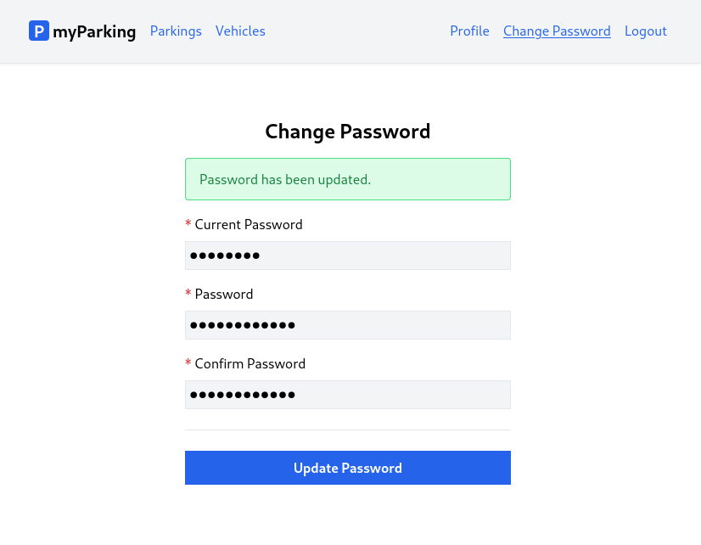
Before we start implementing, let's first discuss why we can't have the password fields on the same profile page. While some websites or applications have this, it also brings up new issues:
- The idea of leaving the password fields blank to keep the same password can be confusing for users.
- It can be misinterpreted as there is no password.
- Displaying the fields as required can add to the confusion.
- It can be unclear how to mark the fields when they are all required if any of them is filled.
- If all fields are required, why do you need to change the password just to update the name?
- Validating the submitted form on the backend becomes more complex and now have to handle both account details and password changes which we think are separate concerns.
Having a separate form specifically for changing passwords solves all of these problems and benefits both users and developers. With that in mind, let's implement the form.
- Create a new src/hooks/usePassword.jsx hook.
import { useState } from 'react'

export function usePassword() {
const [errors, setErrors] = useState({})
const [loading, setLoading] = useState(false)
const [status, setStatus] = useState('')

async function updatePassword(data) {
setLoading(true)
setErrors({})
setStatus('')

return axios.put('password', data)
.then(() => setStatus('Password has been updated.'))
.catch(error => {
if (error.response.status === 422) {
setErrors(error.response.data.errors)
}
})
.finally(() => setLoading(false))
}

return { errors, loading, status, updatePassword }
}
- Create a new src/views/profile/ChangePassword.jsx component.
import { useState } from 'react'
import { usePassword } from '@/hooks/usePassword'
import ValidationError from '@/components/ValidationError'
import IconSpinner from '@/components/IconSpinner'

function ChangePassword() {
const [currentPassword, setCurrentPassword] = useState('')
const [password, setPassword] = useState('')
const [passwordConfirmation, setPasswordConfirmation] = useState('')
const { errors, loading, status, updatePassword } = usePassword()

async function handleSubmit(event) {
event.preventDefault()

await updatePassword({
current_password: currentPassword,
password,
password_confirmation: passwordConfirmation,
})

setCurrentPassword('')
setPassword('')
setPasswordConfirmation('')
}

return (
<form onSubmit={ handleSubmit } noValidate>
<div className="flex flex-col mx-auto md:w-96 w-full">

<h1 className="heading">Change Password</h1>

{ status &&
<div className="alert alert-success mb-4" role="alert">
{ status }
</div>
}

<div className="flex flex-col gap-2 mb-4">
<label htmlFor="current_password" className="required">Current Password</label>
<input
id="current_password"
name="current_password"
type="password"
value={ currentPassword }
onChange={ event => setCurrentPassword(event.target.value) }
className="form-input"
autoComplete="current-password"
disabled={ loading }
/>
<ValidationError errors={ errors } field="current_password" />
</div>

<div className="flex flex-col gap-2 mb-4">
<label htmlFor="password" className="required">Password</label>
<input
id="password"
name="password"
type="password"
value={ password }
onChange={ event => setPassword(event.target.value) }
className="form-input"
autoComplete="new-password"
disabled={ loading }
/>
<ValidationError errors={ errors } field="password" />
</div>

<div className="flex flex-col gap-2">
<label htmlFor="password_confirmation" className="required">Confirm Password</label>
<input
id="password_confirmation"
name="password_confirmation"
type="password"
value={ passwordConfirmation }
onChange={ event => setPasswordConfirmation(event.target.value) }
className="form-input"
autoComplete="new-password"
disabled={ loading }
/>
</div>

<div className="border-t h-[1px] my-6"></div>

<div className="flex flex-col gap-2 mb-4">
<button type="submit" className="btn btn-primary" disabled={ loading }>
{ loading && <IconSpinner /> }
Update Password
</button>
</div>
</div>
</form>
)
}

export default ChangePassword
- Add a new profile.change-password named route to the src/routes/index.jsx file.
const routeNames = {
'home': '/',
'register': '/register',
'login': '/login',
'profile.edit': '/profile',
'profile.change-password': '/profile/change-password',
'vehicles.index': '/vehicles',
'parkings.active': '/parkings/active',
}
- Import the ChangePassword component and bind the route in the src/main.jsx file.
import ChangePassword from '@/views/profile/ChangePassword'
<Route path={ route('profile.change-password') } element={<ChangePassword />} />
- And finally add a link to change the password view in the rightAuthLinks function on the src/App.jsx file.
function rightAuthLinks() {
return <>
<NamedLink name="profile.edit">
Profile
</NamedLink>
<NamedLink name="profile.change-password">
Change Password
</NamedLink>
<button onClick={ logout } type="button" className="text-blue-600">
Logout
</button>
</>
}
In order to be able to book parking in a specific zone, the user must first add their own vehicles. This lesson will focus on implementing the first CRUD operation.
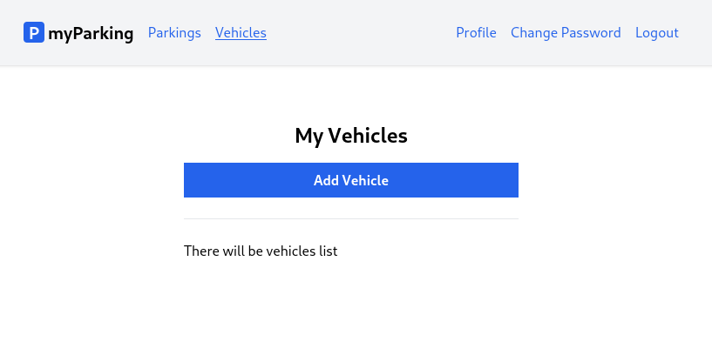
And the form to add a vehicle will look like this. After pressing the Save Vehicle button form is submitted to the server and then redirected back to the list. Pressing the Cancel button redirect will discard the form data without submitting it and will redirect back to the list.
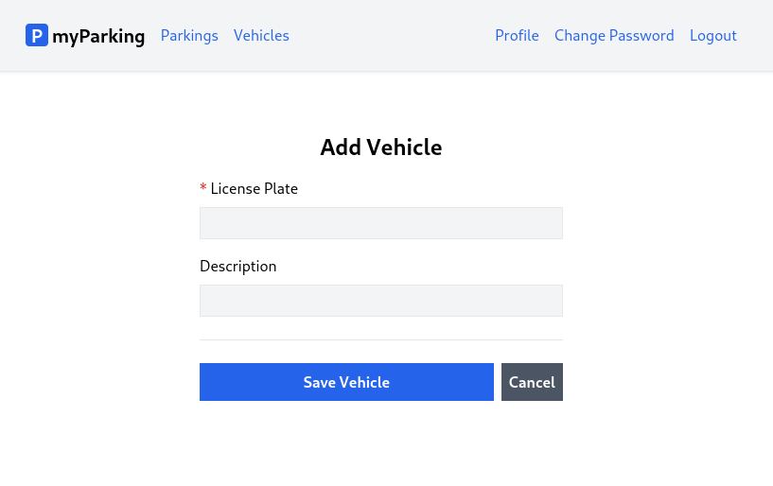
- Create a new src/hooks/useVehicle.jsx hook.
import { useState } from 'react'
import { useNavigate } from 'react-router-dom'
import { route } from '@/routes'

export function useVehicle() {
const [errors, setErrors] = useState({})
const [loading, setLoading] = useState(false)
const [data, setData] = useState({})
const navigate = useNavigate()

function createVehicle(data) {
setLoading(true)
setErrors({})

return axios.post('vehicles', data)
.then(() => navigate(route('vehicles.index')))
.catch(error => {
if (error.response.status === 422) {
setErrors(error.response.data.errors)
}
})
.finally(() => setLoading(false))
}

return {
vehicle: { data, setData, errors, loading },
createVehicle,
}
}
- Create a new src/views/vehicles/CreateVehicle.jsx component.
import { useNavigate } from 'react-router-dom'
import { useVehicle } from '@/hooks/useVehicle'
import { route } from '@/routes'
import ValidationError from '@/components/ValidationError'
import IconSpinner from '@/components/IconSpinner'

function CreateVehicle() {
const { vehicle, createVehicle } = useVehicle()
const navigate = useNavigate()

async function handleSubmit(event) {
event.preventDefault()

await createVehicle(vehicle.data)
}

return (
<form onSubmit={ handleSubmit } noValidate>
<div className="flex flex-col mx-auto md:w-96 w-full">

<h1 className="heading">Add Vehicle</h1>

<div className="flex flex-col gap-2 mb-4">
<label htmlFor="plate_number" className="required">License Plate</label>
<input
id="plate_number"
name="plate_number"
type="text"
value={ vehicle.data.plate_number ?? '' }
onChange={ event => vehicle.setData({
...vehicle.data,
plate_number: event.target.value,
}) }
className="form-input plate"
disabled={ vehicle.loading }
/>
<ValidationError errors={ vehicle.errors } field="plate_number" />
</div>

<div className="flex flex-col gap-2">
<label htmlFor="description">Description</label>
<input
id="description"
name="description"
type="text"
value={ vehicle.data.description ?? '' }
onChange={ event => vehicle.setData({
...vehicle.data,
description: event.target.value,
}) }
className="form-input"
disabled={ vehicle.loading }
/>
<ValidationError errors={ vehicle.errors } field="email" />
</div>

<div className="border-t h-[1px] my-6"></div>

<div className="flex items-center gap-2">
<button
type="submit"
className="btn btn-primary w-full"
disabled={ vehicle.loading }
>
{ vehicle.loading && <IconSpinner /> }
Save Vehicle
</button>

<button
type="button"
className="btn btn-secondary"
disabled={ vehicle.loading }
onClick={ () => navigate(route('vehicles.index')) }
>
<span>Cancel</span>
</button>
</div>
</div>
</form>
)
}

export default CreateVehicle
For the cancel action, we created a regular button with the type="button" attribute, and added an onClick handler with an anonymous function to navigate to the vehicles.index named route.
<button
type="button"
className="btn btn-secondary"
disabled={ vehicle.loading }
onClick={ () => navigate(route('vehicles.index')) }
>
<span>Cancel</span>
</button>
We didn't use Link or NavLink for this purpose because they don't support the disabled property and we want to prevent cancel action while the form is being processed.
- Add a new named route 'vehicles.create': '/vehicles/create', in the src/routes/index.jsx file.
const routeNames = {
'home': '/',
'register': '/register',
'login': '/login',
'profile.edit': '/profile',
'profile.change-password': '/profile/change-password',
'vehicles.index': '/vehicles',
'vehicles.create': '/vehicles/create',
'parkings.active': '/parkings/active',
}
- Update src/main.jsx by importing the newly created component.
import CreateVehicle from '@/views/vehicles/CreateVehicle'
and defining a route for it
<Route path={ route('vehicles.create') } element={<CreateVehicle />} />
- Finally update src/views/vehicles/VehiclesList.jsx with the following content to have a link to the vehicles.create form.
import { Link } from 'react-router-dom'
import { route } from '@/routes'

function VehiclesList() {
return (
<div className="flex flex-col mx-auto md:w-96 w-full">

<h1 className="heading">My Vehicles</h1>

<Link to={ route('vehicles.create') } className="btn btn-primary">
Add Vehicle
</Link>

<div className="border-t h-[1px] my-6"></div>

<div>There will be vehicles list</div>
</div>
)
}

export default VehiclesList
Let's move forward to the next lesson and display the vehicles list on the client.
Our objective for this lesson should be to display a list of the user's vehicles after a new vehicle has been added to their account.
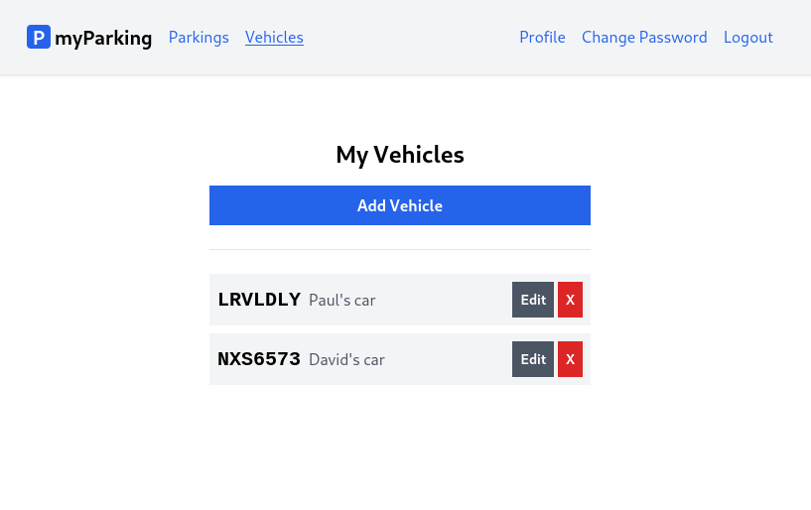
- Create new src/hooks/useVehicles.jsx hook.
It will fetch vehicle data automatically using useEffect as we did with the profile.
import { useState, useEffect } from 'react'

export function useVehicles() {
const [vehicles, setVehicles] = useState([])

useEffect(() => {
const controller = new AbortController()
getVehicles({ signal: controller.signal })
return () => { controller.abort() }
}, [])

async function getVehicles({ signal } = {}) {
return axios.get('vehicles', { signal })
.then(response => setVehicles(response.data.data))
.catch(() => {})
}

return { vehicles }
}
All we need to do now is just grab the vehicles array and display data returned from API.
- Update the src/views/vehicles/VehiclesList.jsx component with the following content.
import { Link } from 'react-router-dom'
import { route } from '@/routes'
import { useVehicles } from '@/hooks/useVehicles'

function VehiclesList() {
const { vehicles } = useVehicles()

return (
<div className="flex flex-col mx-auto md:w-96 w-full">

<h1 className="heading">My Vehicles</h1>

<Link to={ route('vehicles.create') } className="btn btn-primary">
Add Vehicle
</Link>

<div className="border-t h-[1px] my-6"></div>

<div className="flex flex-col gap-2">
{ vehicles.length > 0 && vehicles.map(vehicle => {
return (
<div
key={ vehicle.id }
className="flex bg-gray-100 w-full p-2 justify-between"
>
<div className="flex items-center overflow-hidden w-full">
<div className="text-xl plate">
{ vehicle.plate_number }
</div>
<div className="font-normal text-gray-600 pl-2 grow truncate">
{ vehicle.description }
</div>
</div>
<div className="flex gap-1">
<button type="button" className="btn btn-secondary text-sm">
Edit
</button>
<button type="button" className="btn text-white bg-red-600 hover:bg-red-500 text-sm">
X
</button>
</div>
</div>
)
})}
</div>
</div>
)
}

export default VehiclesList
We will often need to display multiple similar components from a collection of data. We can use the JavaScript array methods to manipulate an array of data. This can be easily achieved using the following structure.
{ data.length > 0 && data.map(o => <div>{ o }</div>) }
In our case, we iterate over vehicles and map them to a new array of JSX nodes which will be rendered.
{ vehicles.length > 0 && vehicles.map(vehicle => {
return (
<div key={ vehicle.id } >
{/* ... */}
</div>
)
})}
To keep items in order we need to give each array item a key - a string or a number that uniquely identifies it among other items in that array:
<div key={ vehicle.id } >
JSX elements directly inside a map() call always need keys.
Keys tell React which array item each component corresponds to so that it can match them up later. This becomes important if your array items can move (e.g. due to sorting), get inserted, or get deleted. Keys must be unique.
The vehicle id is perfectly suitable for that.
To display the value of an object we can use this syntax.
{ vehicle.plate_number }
It will be replaced with the value of the vehicle.plate_number property from the vehicle object.
Each list item also contains Edit and Remove buttons which we're going to implement next lessons.
In this lesson, we will incorporate an edit form into the vehicle's CRUD operation. This form will be similar to the create form, except it will have a different URL /vehicles/:id/edit. The data of a specific vehicle will be retrieved from the API using the :id URL parameter.
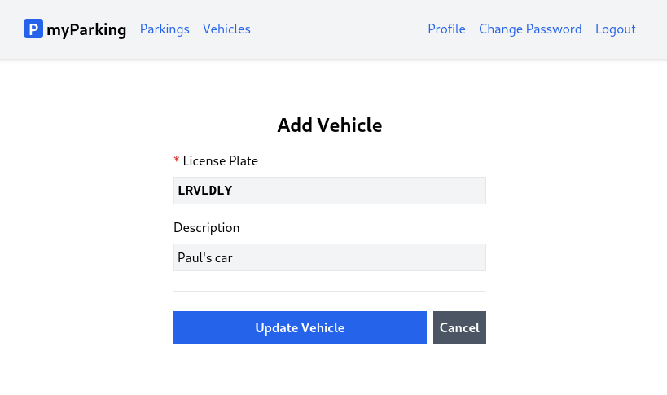
- Update the src/hooks/useVehicle.jsx hook with the following content.
import { useState, useEffect } from 'react'
import { useNavigate } from 'react-router-dom'
import { route } from '@/routes'

export function useVehicle(id = null) {
const [errors, setErrors] = useState({})
const [loading, setLoading] = useState(false)
const [data, setData] = useState({})
const navigate = useNavigate()

useEffect(() => {
if (id !== null) {
const controller = new AbortController()
getVehicle(id, { signal: controller.signal })
return () => controller.abort()
}
}, [id])

async function createVehicle(vehicle) {
setLoading(true)
setErrors({})

return axios.post('vehicles', vehicle)
.then(() => navigate(route('vehicles.index')))
.catch(error => {
if (error.response.status === 422) {
setErrors(error.response.data.errors)
}
})
.finally(() => setLoading(false))
}

async function getVehicle(id, { signal } = {}) {
setLoading(true)

return axios.get(`vehicles/${id}`, { signal })
.then(response => setData(response.data.data))
.catch(() => {})
.finally(() => setLoading(false))
}

async function updateVehicle(vehicle) {
setLoading(true)
setErrors({})

return axios.put(`vehicles/${vehicle.id}`, vehicle)
.then(() => navigate(route('vehicles.index')))
.catch(error => {
if (error.response.status === 422) {
setErrors(error.response.data.errors)
}
})
.finally(() => setLoading(false))
}

return {
vehicle: { data, setData, errors, loading },
createVehicle,
updateVehicle,
}
}
In the src/hooks/useVehicle.jsx hook, we have two additional methods:
- updateVehicle - This will be invoked when the form is submitted, and like the createVehicle function, it will redirect us to the VehiclesList if the request is successful. It takes a vehicle object as a parameter.
- getVehicle - This retrieves data for a specific vehicle and updates the form fields to be edited. It takes the id of the vehicle as a parameter and, if needed, a signal from an AbortController.
The useVehicle hook now takes an optional parameter id with a default value of null.
export function useVehicle(id = null) {
If the id parameter is supplied, the useEffect hook will automatically fetch vehicle data using the getVehicle function and update the data state when the component is mounted.
useEffect(() => {
if (id !== null) {
const controller = new AbortController()
getVehicle(id, { signal: controller.signal })
return () => controller.abort()
}
}, [id])
Note that we have defined [id] on useEffect's dependencies. In case you decide to change the id parameter programmatically vehicle data will be re-fetched.
And to return the statement was added updateVehicle function.
return {
vehicle: { data, setData, errors, loading },
createVehicle,
updateVehicle,
}
- Create a new src/views/vehicles/EditVehicle.jsx component with the following content.
import { useNavigate, useParams } from 'react-router-dom'
import { useVehicle } from '@/hooks/useVehicle'
import { route } from '@/routes'
import ValidationError from '@/components/ValidationError'
import IconSpinner from '@/components/IconSpinner'

function EditVehicle() {
const params = useParams()
const { vehicle, updateVehicle } = useVehicle(params.id)
const navigate = useNavigate()

async function handleSubmit(event) {
event.preventDefault()

await updateVehicle(vehicle.data)
}

return (
<form onSubmit={ handleSubmit } noValidate>
<div className="flex flex-col mx-auto md:w-96 w-full">

<h1 className="heading">Add Vehicle</h1>

<div className="flex flex-col gap-2 mb-4">
<label htmlFor="plate_number" className="required">License Plate</label>
<input
id="plate_number"
name="plate_number"
type="text"
value={ vehicle.data.plate_number ?? '' }
onChange={ event => vehicle.setData({
...vehicle.data,
plate_number: event.target.value,
}) }
className="form-input plate"
disabled={ vehicle.loading }
/>
<ValidationError errors={ vehicle.errors } field="plate_number" />
</div>

<div className="flex flex-col gap-2">
<label htmlFor="description">Description</label>
<input
id="description"
name="description"
type="text"
value={ vehicle.data.description ?? '' }
onChange={ event => vehicle.setData({
...vehicle.data,
description: event.target.value,
}) }
className="form-input"
disabled={ vehicle.loading }
/>
<ValidationError errors={ vehicle.errors } field="email" />
</div>

<div className="border-t h-[1px] my-6"></div>

<div className="flex items-center gap-2">
<button
type="submit"
className="btn btn-primary w-full"
disabled={ vehicle.loading }
>
{ vehicle.loading && <IconSpinner /> }
Update Vehicle
</button>

<button
type="button"
className="btn btn-secondary"
disabled={ vehicle.loading }
onClick={ () => navigate(route('vehicles.index')) }
>
<span>Cancel</span>
</button>
</div>
</div>
</form>
)
}

export default EditVehicle
- Define the named route vehicles.edit in the src/routes/index.jsx file.
const routeNames = {
'home': '/',
'register': '/register',
'login': '/login',
'profile.edit': '/profile',
'profile.change-password': '/profile/change-password',
'vehicles.index': '/vehicles',
'vehicles.create': '/vehicles/create',
'vehicles.edit': '/vehicles/:id/edit',
'parkings.active': '/parkings/active',
}
- Import the EditVehicle component and declare the route for that component in the src/main.jsx file.
import EditVehicle from '@/views/vehicles/EditVehicle'
<Route path={ route('vehicles.edit') } element={<EditVehicle />} />
The full content looks like this:
import React from 'react'
import ReactDOM from 'react-dom/client'
import { BrowserRouter, Routes, Route } from 'react-router-dom'
import axios from 'axios'
import App from '@/App'
import Home from '@/views/Home'
import Register from '@/views/auth/Register'
import Login from '@/views/auth/Login'
import EditProfile from '@/views/profile/EditProfile'
import ChangePassword from '@/views/profile/ChangePassword'
import VehiclesList from '@/views/vehicles/VehiclesList'
import CreateVehicle from '@/views/vehicles/CreateVehicle'
import EditVehicle from '@/views/vehicles/EditVehicle'
import ActiveParkings from '@/views/parkings/ActiveParkings'
import '@/assets/main.css'
import { route } from '@/routes'

window.axios = axios
window.axios.defaults.headers.common['X-Requested-With'] = 'XMLHttpRequest'
window.axios.defaults.withCredentials = true
window.axios.defaults.baseURL = 'http://parkingapi.test/api/v1'

ReactDOM.createRoot(document.getElementById('root')).render(
<React.StrictMode>
<BrowserRouter>
<Routes>
<Route path={ route('home') } element={<App />}>
<Route index element={<Home />} />
<Route path={ route('register') } element={<Register />} />
<Route path={ route('login') } element={<Login />} />
<Route path={ route('profile.edit') } element={<EditProfile />} />
<Route path={ route('profile.change-password') } element={<ChangePassword />} />
<Route path={ route('vehicles.index') } element={<VehiclesList />} />
<Route path={ route('vehicles.create') } element={<CreateVehicle />} />
<Route path={ route('vehicles.edit') } element={<EditVehicle />} />
<Route path={ route('parkings.active') } element={<ActiveParkings />} />
</Route>
</Routes>
</BrowserRouter>
</React.StrictMode>,
)
The line <Route path={ route('vehicles.edit') } element={<EditVehicle />} /> will be evaluated to this:
<Route path="/vehicles/:id/edit" element={<EditVehicle />} />
Now let's go through new things.

Dynamic Routing
Very often we will need to map routes with the given pattern to the same component. We have the src/views/vehicles/EditVehicle.jsx component which should be rendered for all vehicles but with different vehicle IDs. In React Router we can use a dynamic segment in the path to achieving this. We call that a param.
Now URLs like /vehicles/1/edit and /vehicles/3/edit will both map to the same route.
A param is denoted by a colon :. When a route is matched, the value of its params will be exposed as params.id in the VehicleEdit component.
To access route parameters we need to import the useParams hook.
import { useNavigate, useParams } from 'react-router-dom'
const params = useParams()
const { vehicle, updateVehicle } = useVehicle(params.id)
And we pass that value to the useVehicle hook.
- To get the edit button working when we press it in the src/views/vehicles/VehiclesList.jsx component replace this part:
From
<button type="button" className="btn btn-secondary text-sm">
Edit
</button>
To
<Link
to={ route('vehicles.edit', { id: vehicle.id }) }
className="btn btn-secondary text-sm"
>
Edit
</Link>
It is important to note that when calling the route function, we pass an additional parameter id along with vehicle.id. This replaces the :id portion in our path with the actual id of the vehicle that we want to edit.
The full contents of this file look like this.
import { Link } from 'react-router-dom'
import { route } from '@/routes'
import { useVehicles } from '@/hooks/useVehicles'

function VehiclesList() {
const { vehicles } = useVehicles()

return (
<div className="flex flex-col mx-auto md:w-96 w-full">

<h1 className="heading">My Vehicles</h1>

<Link to={ route('vehicles.create') } className="btn btn-primary">
Add Vehicle
</Link>

<div className="border-t h-[1px] my-6"></div>

<div className="flex flex-col gap-2">
{ vehicles.length > 0 && vehicles.map(vehicle => {
return (
<div
key={ vehicle.id }
className="flex bg-gray-100 w-full p-2 justify-between"
>
<div className="flex items-center overflow-hidden w-full">
<div className="text-xl plate">
{ vehicle.plate_number }
</div>
<div className="font-normal text-gray-600 pl-2 grow truncate">
{ vehicle.description }
</div>
</div>
<div className="flex gap-1">
<Link
to={ route('vehicles.edit', { id: vehicle.id }) }
className="btn btn-secondary text-sm"
>
Edit
</Link>
<button type="button" className="btn text-white bg-red-600 hover:bg-red-500 text-sm">
X
</button>
</div>
</div>
)
})}
</div>
</div>
)
}

export default VehiclesList
Now let's move to the next lesson and implement the delete button.
The final step in completing the vehicle's CRUD operation is to implement the delete button functionality in the index view. This should be a quick and straightforward process.
- Extend the src/hooks/useVehicle.jsx hook.
Add a new destroyVehicle function.
async function destroyVehicle(vehicle) {
return axios.delete(`vehicles/${vehicle.id}`)
}
And return it along with the other function in return statements.
return {
vehicle: { data, setData, errors, loading },
createVehicle,
updateVehicle,
destroyVehicle,
}
The whole src/hooks/useVehicle.jsx file has the following content.
import { useState, useEffect } from 'react'
import { useNavigate } from 'react-router-dom'
import { route } from '@/routes'

export function useVehicle(id = null) {
const [errors, setErrors] = useState({})
const [loading, setLoading] = useState(false)
const [data, setData] = useState({})
const navigate = useNavigate()

useEffect(() => {
if (id !== null) {
const controller = new AbortController()
getVehicle(id, { signal: controller.signal })
return () => controller.abort()
}
}, [id])

async function createVehicle(vehicle) {
setLoading(true)
setErrors({})

return axios.post('vehicles', vehicle)
.then(() => navigate(route('vehicles.index')))
.catch(error => {
if (error.response.status === 422) {
setErrors(error.response.data.errors)
}
})
.finally(() => setLoading(false))
}

async function getVehicle(id, { signal } = {}) {
setLoading(true)

return axios.get(`vehicles/${id}`, { signal })
.then(response => setData(response.data.data))
.catch(() => {})
.finally(() => setLoading(false))
}

async function updateVehicle(vehicle) {
setLoading(true)
setErrors({})

return axios.put(`vehicles/${vehicle.id}`, vehicle)
.then(() => navigate(route('vehicles.index')))
.catch(error => {
if (error.response.status === 422) {
setErrors(error.response.data.errors)
}
})
.finally(() => setLoading(false))
}

async function destroyVehicle(vehicle) {
return axios.delete(`vehicles/${vehicle.id}`)
}

return {
vehicle: { data, setData, errors, loading },
createVehicle,
updateVehicle,
destroyVehicle,
}
}
- Extend the src/hooks/useVehicles.jsx hook by exposing the getVehicles function in the return statement, we need to call this function outside of the hook when we delete the vehicle record to re-fetch the list.
return { vehicles, getVehicles }
The whole src/hooks/useVehicles.jsx file has the following content.
import { useState, useEffect } from 'react'

export function useVehicles() {
const [vehicles, setVehicles] = useState([])

useEffect(() => {
const controller = new AbortController()
getVehicles({ signal: controller.signal })
return () => { controller.abort() }
}, [])

async function getVehicles({ signal } = {}) {
return axios.get('vehicles', { signal })
.then(response => setVehicles(response.data.data))
.catch(() => {})
}

return { vehicles, getVehicles }
}
- Update the src/views/vehicles/VehiclesList.jsx component as follows.
Import the useVehicle hook and destructure return contents to have the destroyVehicle function in scope.
import { useVehicle } from '@/hooks/useVehicle'

// ...

const { destroyVehicle } = useVehicle()
Do the same with the useVehicles and getVehicles functions.
const { vehicles, getVehicles } = useVehicles()
Now we can update the button itself.
From
<button type="button" className="btn text-white bg-red-600 hover:bg-red-500 text-sm">
To
<button
type="button"
className="btn text-white bg-red-600 hover:bg-red-500 text-sm"
onClick={ async () => {
await destroyVehicle(vehicle)
await getVehicles()
} }
>
X
</button>
Here we just added an onClick handler to the button. First, send a request to the server to delete a vehicle, and re-fetch the whole vehicles list.
The full src/views/vehicles/VehiclesList.jsx file now should have the following content.
import { Link } from 'react-router-dom'
import { route } from '@/routes'
import { useVehicles } from '@/hooks/useVehicles'
import { useVehicle } from '@/hooks/useVehicle'

function VehiclesList() {
const { vehicles, getVehicles } = useVehicles()
const { destroyVehicle } = useVehicle()

return (
<div className="flex flex-col mx-auto md:w-96 w-full">

<h1 className="heading">My Vehicles</h1>

<Link to={ route('vehicles.create') } className="btn btn-primary">
Add Vehicle
</Link>

<div className="border-t h-[1px] my-6"></div>

<div className="flex flex-col gap-2">
{ vehicles.length > 0 && vehicles.map(vehicle => {
return (
<div
key={ vehicle.id }
className="flex bg-gray-100 w-full p-2 justify-between"
>
<div className="flex items-center overflow-hidden w-full">
<div className="text-xl plate">
{ vehicle.plate_number }
</div>
<div className="font-normal text-gray-600 pl-2 grow truncate">
{ vehicle.description }
</div>
</div>
<div className="flex gap-1">
<Link
to={ route('vehicles.edit', { id: vehicle.id }) }
className="btn btn-secondary text-sm"
>
Edit
</Link>
<button
type="button"
className="btn text-white bg-red-600 hover:bg-red-500 text-sm"
onClick={ async () => {
await destroyVehicle(vehicle)
await getVehicles()
} }
>
X
</button>
</div>
</div>
)
})}
</div>
</div>
)
}

export default VehiclesList
Well done! You have successfully completed the implementation of full functionality for the user's vehicles. Now, let's move on to the next lesson and implement parking.
Time to create a form to allow users to start parking by choosing one of the vehicles they added to their account and selecting the zone.
- To start parking create a new src/hooks/useParking.jsx hook with the startParking function which will submit vehicle and zone ids to API.
import { useState } from 'react'
import { useNavigate } from 'react-router-dom'
import { route } from '@/routes'

export function useParking() {
const navigate = useNavigate()
const [errors, setErrors] = useState({})
const [loading, setLoading] = useState(false)

async function startParking(data) {
return axios.post('parkings/start', data)
.then(() => navigate(route('parkings.active')))
.catch(error => {
if (error.response.status === 422) {
setErrors(error.response.data.errors)
}
})
.finally(() => setLoading(false))
}

return { loading, errors, startParking }
}
- Create a new src/hooks/useZones.jsx hook with the getZones function. This will provide us with data about available parking zones to choose from.
import { useState, useEffect } from 'react'

export function useZones() {
const [zones, setZones] = useState([])

useEffect(() => {
const controller = new AbortController()
getZones({ signal: controller.signal })
return () => { controller.abort() }
}, [])

async function getZones({ signal } = {}) {
return axios.get('zones', { signal })
.then(response => setZones(response.data.data))
.catch(() => {})
}

return { zones }
}
- This is where it gets more interesting. Create a new src/views/parkings/OrderParking.jsx component.
import { useState, useEffect } from 'react'
import { useNavigate } from 'react-router-dom'
import { route } from '@/routes'
import ValidationError from '@/components/ValidationError'
import IconSpinner from '@/components/IconSpinner'
import { useVehicles } from '@/hooks/useVehicles'
import { useZones } from '@/hooks/useZones'
import { useParking } from '@/hooks/useParking'

function OrderParking() {
const navigate = useNavigate()
const { errors, loading, startParking } = useParking()
const { zones } = useZones()
const { vehicles } = useVehicles()
const [vehicle_id, setVehicleId] = useState()
const [zone_id, setZoneId] = useState()

useEffect(() => setVehicleId(vehicles[0]?.id), [vehicles])
useEffect(() => setZoneId(zones[0]?.id), [zones])

async function handleSubmit(event) {
event.preventDefault()

await startParking({ vehicle_id, zone_id })
}

return (
<form onSubmit={ handleSubmit } noValidate>
<div className="flex flex-col mx-auto md:w-96 w-full">

<h1 className="heading">Order Parking</h1>

<div className="flex flex-col gap-2 mb-4">
<label htmlFor="vehicle_id" className="required">Vehicle</label>
<select
id="vehicle_id"
className="form-input"
value={ vehicle_id }
onChange={ (event) => setVehicleId(event.target.value) }
disabled={ loading }
>
{ vehicles.length > 0 && vehicles.map((vehicle) => {
return <option key={ vehicle.id } value={ vehicle.id }>
{ vehicle.plate_number.toUpperCase() }{' '}
{ vehicle.description && '('+vehicle.description+')' }
</option>
}) }
</select>
<ValidationError errors={ errors } field="vehicle_id" />
</div>

<div className="flex flex-col gap-2">
<label htmlFor="zone_id" className="required">Zone</label>
<select
name="zone_id"
id="zone_id"
value={ zone_id }
className="form-input"
onChange={ (event) => setZoneId(event.target.value) }
disabled={ loading }
>
{ zones.length > 0 && zones.map((zone) => {
return <option key={ zone.id } value={ zone.id }>
{ zone.name }{' '}
({ (zone.price_per_hour / 100).toFixed(2) } &euro;/h)
</option>
}) }
</select>
<ValidationError errors={ errors } field="zone_id" />
<ValidationError errors={ errors } field="general" />
</div>

<div className="border-t h-[1px] my-6"></div>

<div className="flex items-center gap-2">
<button
type="submit"
className="btn btn-primary w-full"
disabled={ loading }
>
{ loading && <IconSpinner /> }
Start Parking
</button>

<button
type="button"
className="btn btn-secondary"
disabled={ loading }
onClick={ () => navigate(route('parkings.active')) }
>
<span>Cancel</span>
</button>
</div>
</div>
</form>
)
}

export default OrderParking
We have all three hooks imported.
const { errors, loading, startParking } = useParking()
const { zones } = useZones()
const { vehicles } = useVehicles()
useParking - provides us with errors, loading state, and startParking functions. useZones - gives us an array of zones, it fetches them automatically. useVehicles - provides us with an array of vehicles. We have created this in previous lessons. The whole reason to separate business logic into hooks is that we can later reuse it without the need to implement it once again.
vehicle_id and zone_id will be used to store we chose from <select> dropdown.
const [vehicle_id, setVehicleId] = useState()
const [zone_id, setZoneId] = useState()
The <select> dropdown has the following structure:
<select
value={ vehicle_id }
onChange={ (event) => setVehicleId(event.target.value) }
disabled={ loading }
>
{ vehicles.length > 0 && vehicles.map((vehicle) => {
return <option key={ vehicle.id } value={ vehicle.id }>
{ vehicle.plate_number.toUpperCase() }{' '}
{ vehicle.description && '('+vehicle.description+')' }
</option>
}) }
</select>
It has the same value property as the <input> field to represent the current state of vehicle_id. onChange handler will update the corresponding state variable when we choose the particular <option>.
To display all options with vehicles available we iterate them using vehicles.length > 0 && vehicles.map() as we did in the vehicles index view. When using the array method map we always need to define the key property with a unique value to let JSX keep track of nodes.
When we load the form none of our options will be selected by default and the default attribute selected doesn't work there.
Initially vehicle_id and zone_id have an undefined value, but we do not know what ids are available, so in order to do that we need to update vehicle_id and zone_id after we fetch the lists of vehicles and zones. This is done by using the useEffect hook, vehicles are added to the dependencies list, so when the value changes it calls setVehicleId with the id from the first element. The same applies to zones.
useEffect(() => setVehicleId(vehicles[0]?.id), [vehicles])
useEffect(() => setZoneId(zones[0]?.id), [zones])
On the bottom of the form we have an additional ValidationError component with a field named general.
<ValidationError errors={ errors } field="general" />
general errors are displayed when API returns errors not related to fields. For example, if you try to start parking while having one active on your vehicle.
Finally, we submit the form by calling startParking and providing an object with vehicle_id and zone_id as a parameter.
async function handleSubmit(event) {
event.preventDefault()

await startParking({ vehicle_id, zone_id })
}
It is important to note that the <option> element is pretty limited to styling, this is a reason we didn't apply any CSS classes.
return <option key={ vehicle.id } value={ vehicle.id }>
{ vehicle.plate_number.toUpperCase() }{' '}
{ vehicle.description && '('+vehicle.description+')' }
</option>
Similarly, we format zone options.
To display plate numbers in uppercase we can use JavaScript's string method toUpperCase(). For description, if vehicle.description enumerates to true, we display that description.
return <option key={ zone.id } value={ zone.id }>
{ zone.name }{' '}
({ (zone.price_per_hour / 100).toFixed(2) } &euro;/h)
</option>
zone.price_per_hour is returned in cents from the API. By dividing it by 100 it would give us a result of 1. To always display decimal points we need to use the toFixed() function which is native JavaScript's method for integers and floats. How many decimal points to display is specified by a parameter, in our case, it is toFixed(2). For the euro currency sign in HTML, there is a &euro; code.
- Add the parkings.create route to the src/routes/index.jsx file.
const routeNames = {
'home': '/',
'register': '/register',
'login': '/login',
'profile.edit': '/profile',
'profile.change-password': '/profile/change-password',
'vehicles.index': '/vehicles',
'vehicles.create': '/vehicles/create',
'vehicles.edit': '/vehicles/:id/edit',
'parkings.active': '/parkings/active',
'parkings.create': '/parkings/new',
}
- Import the OrderParking component and define the route in the src/main.jsx file.
import OrderParking from '@/views/parkings/OrderParking'
<Route path={ route('parkings.create') } element={<OrderParking />} />
- And finally update the src/views/parkings/ActiveParkings.jsx component with the following content.
import { Link } from 'react-router-dom'
import { route } from '@/routes'

function ActiveParkings() {
return (
<div className="flex flex-col mx-auto md:w-96 w-full">

<h1 className="heading">Active Parkings</h1>

<Link to={ route('parkings.create') } className="btn btn-primary">
Order Parking
</Link>

<div className="border-t h-[1px] my-6"></div>

<div>
There will be active parkings list
</div>
</div>
)
}

export default ActiveParkings
Now we can select a vehicle, zone, and start parking.
In this lesson, we will display an active parking list with a stop button to end parking.
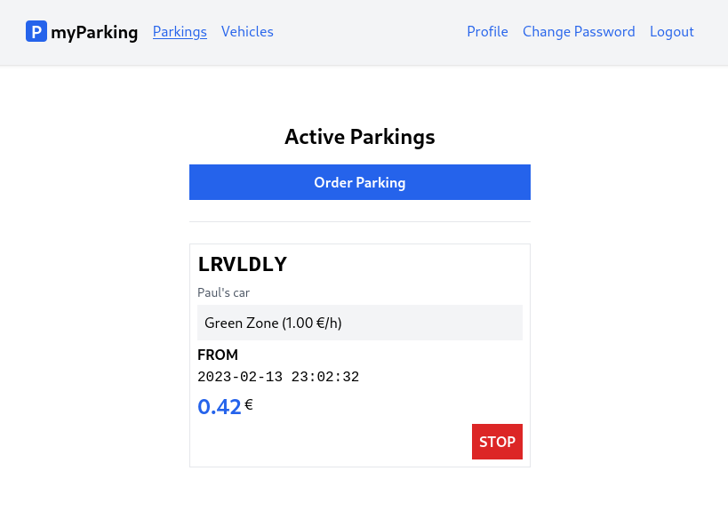
import { useState, useEffect } from 'react'

import { Link } from 'react-router-dom'
import { route } from '@/routes'

function ActiveParkings() {
const [parkings, setParkings] = useState([])

useEffect(() => {
const controller = new AbortController()
getActiveParkings({ signal: controller.signal })
return () => controller.abort()
}, [])

async function getActiveParkings({ signal } = {}) {
return axios.get('parkings', { signal })
.then(response => setParkings(response.data.data))
.catch(() => {})
}

async function stopParking(parking) {
await axios.put(`parkings/${parking.id}`)
await getActiveParkings()
}

return (
<div className="flex flex-col mx-auto md:w-96 w-full">

<h1 className="heading">Active Parkings</h1>

<Link to={ route('parkings.create') } className="btn btn-primary">
Order Parking
</Link>

<div className="border-t h-[1px] my-6"></div>

<div className="flex flex-col gap-1">
{ parkings.length > 0 && parkings.map((parking) => {
return <div
key={ parking.id }
className="flex flex-col p-2 border gap-1"
>
<div className="plate text-2xl">
{ parking.vehicle.plate_number }
</div>
<div className="text-sm text-gray-600">
{ parking.vehicle.description }
</div>
<div className="bg-gray-100 p-2">
{ parking.zone.name }{' '}
({ (parking.zone.price_per_hour / 100).toFixed(2) } &euro;/h)
</div>
<div>
<div className="font-bold uppercase">from</div>
<span className="font-mono">{ parking.start_time }</span>
</div>
<div className="flex items-top">
<span className="text-2xl font-bold text-blue-600">
{ (parking.total_price / 100).toFixed(2) }
</span>
<span className="pt-0.5">&nbsp;&euro;</span>
</div>
<button
type="button"
className="btn btn-danger uppercase ml-auto"
onClick={ () => stopParking(parking) }
>
stop
</button>
</div>
})}
</div>
</div>
)
}

export default ActiveParkings
The getActiveParkings() function will retrieve the list of currently active parkings and update the parkings state. The useEffect hook will call getActiveParkings() when the component is mounted.
const [parkings, setParkings] = useState([])

useEffect(() => {
const controller = new AbortController()
getActiveParkings({ signal: controller.signal })
return () => controller.abort()
}, [])

async function getActiveParkings({ signal } = {}) {
return axios.get('parkings', { signal })
.then(response => setParkings(response.data.data))
.catch(() => {})
}
After the setParkings(response.data.data) call parkings state will have the following structure returned from API.
[
{
"id": 3,
"zone": {
"name": "Red Zone",
"price_per_hour": 300
},
"vehicle": {
"plate_number": "lrvldly",
"description": "Paul's car"
},
"start_time": "2023-02-01 12:58:46",
"stop_time": null,
"total_price": 795
}
]
Since zone.price_per_hour and total_price are retrieved as cents we can format the data in the same fashion we did in the previous lesson. zone.price_per_hour and total_price is formatted using the toFixed() method after division.
{ (parking.zone.price_per_hour / 100).toFixed(2) }
{ (parking.total_price / 100).toFixed(2) }
The stopParking() function will take a parking parameter, allowing it to determine which active parking should be stopped when the stop button is pressed. After the data is fetched, the list of active parkings will be re-rendered.
<button
type="button"
className="btn btn-danger uppercase ml-auto"
onClick={ () => stopParking(parking) }
>
stop
</button>
Now when parking is stopped, it simply disappears from the active parking list. The intention was to separate parking orders into "active" and "history" categories for convenience and clarity.
In this lesson, let's implement the list of parking history.
- Create a new component src/views/parkings/ParkingHistory.jsx.
import { useState, useEffect } from 'react'

function ParkingHistory() {
const [parkings, setParkings] = useState([])

useEffect(() => {
const controller = new AbortController()
getParkingHistory({ signal: controller.signal })
return () => controller.abort()
}, [])

async function getParkingHistory({ signal } = {}) {
return axios.get('parkings/history', { signal })
.then(response => setParkings(response.data.data))
.catch(() => {})
}

return (
<div className="flex flex-col mx-auto md:w-96 w-full">

<h1 className="heading">Parking History</h1>

<div className="flex flex-col gap-1">
{ parkings.length > 0 && parkings.map((parking) => {
return <div
key={ parking.id }
className="flex flex-col p-2 border gap-1"
>
<div className="plate text-2xl">
{ parking.vehicle.plate_number }
</div>
<div className="bg-gray-100 p-2">
{ parking.zone.name }{' '}
({ (parking.zone.price_per_hour / 100).toFixed(2) } &euro;/h)
</div>
<div>
<div className="font-bold uppercase">from</div>
<span className="font-mono">{ parking.start_time }</span>
</div>
<div>
<div className="font-bold uppercase">to</div>
<span className="font-mono">{ parking.stop_time }</span>
</div>
<div className="flex items-top">
<span className="text-2xl font-bold ml-auto">
{ (parking.total_price / 100).toFixed(2) }
</span>
<span className="pt-0.5">&nbsp;&euro;</span>
</div>
<button
type="button"
className="btn btn-secondary uppercase"
>
view details
</button>
</div>
})}
</div>
</div>
)
}

export default ParkingHistory
The ParkingHistory component is very similar to what we did in the previous lesson when we implemented the active parking list. The getParkingHistory function operates in the same way and retrieves data from a different endpoint.
In this lesson, we have added a "view details" button, but it does not yet have an assigned onClick handler. This will be implemented in the next lesson.
- Add a new named route parkings.history to named routes in the src/routes/index.jsx file.
The full content of this file now should look like this.
const routeNames = {
'home': '/',
'register': '/register',
'login': '/login',
'profile.edit': '/profile',
'profile.change-password': '/profile/change-password',
'vehicles.index': '/vehicles',
'vehicles.create': '/vehicles/create',
'vehicles.edit': '/vehicles/:id/edit',
'parkings.active': '/parkings/active',
'parkings.history': '/parkings/history',
'parkings.create': '/parkings/new',
}

function route(name, params = {}) {
let url = routeNames[name]

for (let prop in params) {
if (Object.prototype.hasOwnProperty.call(params, prop)) {
url = url.replace(`:${prop}`, params[prop])
}
}

return url
}

export { route }
- Import the component and map route in the src/main.jsx file.
import ParkingHistory from '@/views/parkings/ParkingHistory'
<Route path={ route('parkings.history') } element={<ParkingHistory />} />
The whole file has the following content.
import React from 'react'
import ReactDOM from 'react-dom/client'
import { BrowserRouter, Routes, Route } from 'react-router-dom'
import axios from 'axios'
import App from '@/App'
import Home from '@/views/Home'
import Register from '@/views/auth/Register'
import Login from '@/views/auth/Login'
import EditProfile from '@/views/profile/EditProfile'
import ChangePassword from '@/views/profile/ChangePassword'
import VehiclesList from '@/views/vehicles/VehiclesList'
import CreateVehicle from '@/views/vehicles/CreateVehicle'
import EditVehicle from '@/views/vehicles/EditVehicle'
import ActiveParkings from '@/views/parkings/ActiveParkings'
import ParkingHistory from '@/views/parkings/ParkingHistory'
import OrderParking from '@/views/parkings/OrderParking'
import '@/assets/main.css'
import { route } from '@/routes'

window.axios = axios
window.axios.defaults.headers.common['X-Requested-With'] = 'XMLHttpRequest'
window.axios.defaults.withCredentials = true
window.axios.defaults.baseURL = 'http://parkingapi.test/api/v1'

ReactDOM.createRoot(document.getElementById('root')).render(
<React.StrictMode>
<BrowserRouter>
<Routes>
<Route path={ route('home') } element={<App />}>
<Route index element={<Home />} />
<Route path={ route('register') } element={<Register />} />
<Route path={ route('login') } element={<Login />} />
<Route path={ route('profile.edit') } element={<EditProfile />} />
<Route path={ route('profile.change-password') } element={<ChangePassword />} />
<Route path={ route('vehicles.index') } element={<VehiclesList />} />
<Route path={ route('vehicles.create') } element={<CreateVehicle />} />
<Route path={ route('vehicles.edit') } element={<EditVehicle />} />
<Route path={ route('parkings.active') } element={<ActiveParkings />} />
<Route path={ route('parkings.history') } element={<ParkingHistory />} />
<Route path={ route('parkings.create') } element={<OrderParking />} />
</Route>
</Routes>
</BrowserRouter>
</React.StrictMode>,
)
- And insert a new link to the parkings.history route in the leftAuthLinks function on the src/App.jsx file.
<NamedLink name="parkings.history">
History
</NamedLink>
Now the file should have this content.
import { Outlet } from 'react-router-dom'
import NamedLink from '@/components/NamedLink'
import { useAuth } from '@/hooks/useAuth'

function App() {
const { isLoggedIn, logout } = useAuth()

axios.interceptors.response.use(
response => response,
error => {
if (error.response?.status === 401) logout(true)
return Promise.reject(error)
},
)

function leftGuestLinks() {
return <>
<NamedLink name="home">
Home
</NamedLink>
</>
}

function leftAuthLinks() {
return <>
<NamedLink name="parkings.active">
Parkings
</NamedLink>
<NamedLink name="vehicles.index">
Vehicles
</NamedLink>
<NamedLink name="parkings.history">
History
</NamedLink>
</>
}

function rightGuestLinks() {
return <>
<NamedLink name="login">
Login
</NamedLink>
<NamedLink name="register">
Register
</NamedLink>
</>
}

function rightAuthLinks() {
return <>
<NamedLink name="profile.edit">
Profile
</NamedLink>
<NamedLink name="profile.change-password">
Change Password
</NamedLink>
<button onClick={ logout } type="button" className="text-blue-600">
Logout
</button>
</>
}

return (
<div className="App">
<header className="py-6 bg-gray-100 shadow">
<div className="container md:px-2 px-4 mx-auto">
<nav className="flex gap-4 justify-between">
<div className="flex gap-4 items-center">
<h2 className="text-xl font-bold">
<div
className="inline-flex items-center justify-center bg-blue-600 w-6 h-6 text-center text-white rounded mr-1"
>
P
</div>
myParking
</h2>
{ isLoggedIn ? leftAuthLinks() : leftGuestLinks() }
</div>
<div className="flex gap-4 items-center">
{ isLoggedIn ? rightAuthLinks() : rightGuestLinks() }
</div>
</nav>
</div>
</header>
<div className="container md:px-2 px-4 pt-8 md:pt-16 mx-auto">
<Outlet />
</div>
</div>
)
}

export default App
On the parking history page, we intentionally excluded some of the information about past parkings that have been archived and included a "view details" button instead.
In this lesson, we will create a parking details page to provide a comprehensive overview of all the information regarding past orders.
- Create a new src/views/parkings/ParkingDetails.jsx component.
import { useState, useEffect } from 'react'
import { useParams, Link } from 'react-router-dom'
import { route } from '@/routes'

function ParkingDetails() {
const { id } = useParams()
const [parking, setParking] = useState(null)

useEffect(() => {
const controller = new AbortController()
getParking(id, { signal: controller.signal })
return () => controller.abort()
}, [id])

async function getParking(id, { signal } = {}) {
return axios.get(`parkings/${id}`, { signal })
.then(response => setParking(response.data.data))
.catch(() => {})
}

return (parking &&
<div className="flex flex-col mx-auto md:w-96 w-full">

<h1 className="heading">Parking order details</h1>

<div className="border p-2 font-mono">
<div className="font-bold uppercase mb-4">
parking order #{ parking.id }
</div>

<div className="font-bold uppercase">license plate</div>
<div className="plate text-2xl">
{ parking.vehicle.plate_number }
</div>

<div className="font-bold uppercase">description</div>
<div>{ parking.vehicle.description }</div>

<div className="font-bold uppercase">zone</div>
<div>{ parking.zone.name }</div>

<div className="font-bold uppercase">price</div>
<div>
{ (parking.zone.price_per_hour / 100).toFixed(2) }{' '}
&euro; per hour
</div>

<div className="font-bold uppercase">from</div>
<div>{ parking.start_time }</div>

<div className="font-bold uppercase">to</div>
<div>{ parking.stop_time }</div>

<div className="font-bold uppercase">total</div>
<div className="text-xl">
{ (parking.total_price / 100).toFixed(2) } &euro;
</div>
</div>

<div className="border-t h-[1px] my-6"></div>

<Link
to={ route('parkings.history') }
className="btn btn-secondary uppercase"
>
return
</Link>
</div>
)
}

export default ParkingDetails
To get the route :id parameter passed to this component via URL we need to import the useParams hook first. Then we can unpack the id value with this line to use later.
const { id } = useParams()
The getParking() function will retrieve the particular parking order record and update the parking state variable. The useEffect hook will call getParking() when the component is mounted by passing the id route parameter.
useEffect(() => {
const controller = new AbortController()
getParking(id, { signal: controller.signal })
return () => controller.abort()
}, [id])

async function getParking(id, { signal } = {}) {
return axios.get(`parkings/${id}`, { signal })
.then(response => setParking(response.data.data))
.catch(() => {})
}
When initializing the parking state we have set its default value to null.
const [parking, setParking] = useState(null)
While there's no data retrieved yet when the component is mounted we want to hide the whole card. This can be done by using AND && operator. The empty object doesn't satisfy this condition because it always evaluates as true.
return (parking &&
<div className="flex flex-col mx-auto md:w-96 w-full">
{/* ... */}
</div>
)
- Update src/routes/index.jsx by adding parkings.show named route. The full content of this file now should look like this.
const routeNames = {
'home': '/',
'register': '/register',
'login': '/login',
'profile.edit': '/profile',
'profile.change-password': '/profile/change-password',
'vehicles.index': '/vehicles',
'vehicles.create': '/vehicles/create',
'vehicles.edit': '/vehicles/:id/edit',
'parkings.active': '/parkings/active',
'parkings.history': '/parkings/history',
'parkings.create': '/parkings/new',
'parkings.show': '/parkings/:id',
}

function route(name, params = {}) {
let url = routeNames[name]

for (let prop in params) {
if (Object.prototype.hasOwnProperty.call(params, prop)) {
url = url.replace(`:${prop}`, params[prop])
}
}

return url
}

export { route }
- Import the newly created component and define a route for that component in the src/main.jsx file.
import ParkingDetails from '@/views/parkings/ParkingDetails'
<Route path={ route('parkings.show') } element={<ParkingDetails />} />
Now it should look like this:
import React from 'react'
import ReactDOM from 'react-dom/client'
import { BrowserRouter, Routes, Route } from 'react-router-dom'
import axios from 'axios'
import App from '@/App'
import Home from '@/views/Home'
import Register from '@/views/auth/Register'
import Login from '@/views/auth/Login'
import EditProfile from '@/views/profile/EditProfile'
import ChangePassword from '@/views/profile/ChangePassword'
import VehiclesList from '@/views/vehicles/VehiclesList'
import CreateVehicle from '@/views/vehicles/CreateVehicle'
import EditVehicle from '@/views/vehicles/EditVehicle'
import ActiveParkings from '@/views/parkings/ActiveParkings'
import ParkingHistory from '@/views/parkings/ParkingHistory'
import OrderParking from '@/views/parkings/OrderParking'
import ParkingDetails from '@/views/parkings/ParkingDetails'
import '@/assets/main.css'
import { route } from '@/routes'

window.axios = axios
window.axios.defaults.headers.common['X-Requested-With'] = 'XMLHttpRequest'
window.axios.defaults.withCredentials = true
window.axios.defaults.baseURL = 'http://parkingapi.test/api/v1'

ReactDOM.createRoot(document.getElementById('root')).render(
<React.StrictMode>
<BrowserRouter>
<Routes>
<Route path={ route('home') } element={<App />}>
<Route index element={<Home />} />
<Route path={ route('register') } element={<Register />} />
<Route path={ route('login') } element={<Login />} />
<Route path={ route('profile.edit') } element={<EditProfile />} />
<Route path={ route('profile.change-password') } element={<ChangePassword />} />
<Route path={ route('vehicles.index') } element={<VehiclesList />} />
<Route path={ route('vehicles.create') } element={<CreateVehicle />} />
<Route path={ route('vehicles.edit') } element={<EditVehicle />} />
<Route path={ route('parkings.active') } element={<ActiveParkings />} />
<Route path={ route('parkings.history') } element={<ParkingHistory />} />
<Route path={ route('parkings.create') } element={<OrderParking />} />
<Route path={ route('parkings.show') } element={<ParkingDetails />} />
</Route>
</Routes>
</BrowserRouter>
</React.StrictMode>,
)
- And finally update the src/views/parkings/ParkingHistory.jsx component.
Import Link and route.
import { Link } from 'react-router-dom'
import { route } from '@/routes'
Replace the "view details" button
<button
type="button"
className="btn btn-secondary uppercase"
>
view details
</button>
With
<Link
to={ route('parkings.show', { id: parking.id }) }
className="btn btn-secondary uppercase"
>
view details
</Link>
The src/views/parkings/ParkingHistory.jsx file now should have the content as follows.
import { useState, useEffect } from 'react'
import { Link } from 'react-router-dom'
import { route } from '@/routes'

function ParkingHistory() {
const [parkings, setParkings] = useState([])

useEffect(() => {
const controller = new AbortController()
getParkingHistory({ signal: controller.signal })
return () => controller.abort()
}, [])

async function getParkingHistory({ signal } = {}) {
return axios.get('parkings/history', { signal })
.then(response => setParkings(response.data.data))
.catch(() => {})
}

return (
<div className="flex flex-col mx-auto md:w-96 w-full">

<h1 className="heading">Parking History</h1>

<div className="flex flex-col gap-1">
{ parkings.length > 0 && parkings.map((parking) => {
return <div
key={ parking.id }
className="flex flex-col p-2 border gap-1"
>
<div className="plate text-2xl">
{ parking.vehicle.plate_number }
</div>
<div className="bg-gray-100 p-2">
{ parking.zone.name }{' '}
({ (parking.zone.price_per_hour / 100).toFixed(2) } &euro;/h)
</div>
<div>
<div className="font-bold uppercase">from</div>
<span className="font-mono">{ parking.start_time }</span>
</div>
<div>
<div className="font-bold uppercase">to</div>
<span className="font-mono">{ parking.stop_time }</span>
</div>
<div className="flex items-top">
<span className="text-2xl font-bold ml-auto">
{ (parking.total_price / 100).toFixed(2) }
</span>
<span className="pt-0.5">&nbsp;&euro;</span>
</div>
<Link
to={ route('parkings.show', { id: parking.id }) }
className="btn btn-secondary uppercase"
>
view details
</Link>
</div>
})}
</div>
</div>
)
}

export default ParkingHistory
And that's it, that's the course!
The final source code is available here on GitHub.

